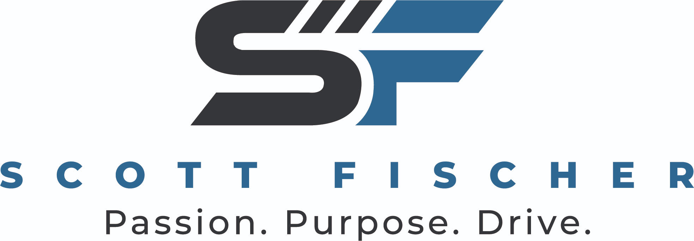

FOR IMMEDIATE RELEASE
LOGO ATTACHED
Milwaukee Harley-Davidson hosts Homecoming Rally July 10-13
MILWAUKEE, Wis. (July 7, 2025) – Motorsports industry veterans and new owners of Milwaukee Harley-Davidson Scott Fischer Enterprises proudly presents the Milwaukee Harley-Davidson’s annual rally in celebration of the Harley-Davidson Homecoming Festival, July 10-13.
A celebration of music, moto-culture and all-things Harley-Davidson, the Milwaukee store’s four-day rally is open to enthusiasts of all ages and features live music, stunt shows, shopping, and food and beverages.
Milwaukee Harley-Davidson kicks off the Homecoming Rally on Thursday, July 10 at 10 a.m. with live music starting at 3 p.m. with Mission Accomplished followed by Rebel Grace at 6 p.m. On Friday, July 11, the music kicks off at 11 a.m. with Geoff London Band, followed by Bad Medicine at 2:30 p.m. and the Hillbilly Rockstarz at 6 p.m. The entertaining Street Cowboys perform their epic cycle stunts at 1:30 p.m., 3:30 p.m. and 5:30 p.m. The lineup for Saturday, July 12 begins at 1 p.m. with Landline, followed by Wapatui at 2:30 p.m. and Breaking Cadence at 6 p.m. A DJ wraps up the festivities on Sunday, July 13 from 11 a.m. to 2 p.m.
Located at 11310 W. Silver Spring Road, Milwaukee Harley-Davidson offers a large selection of new and pre-owned Harley-Davidson motorcycles and a top-quality service and parts department, as well as financing, apparel, events and more.
Scott Fischer Enterprises recently acquired both the Milwaukee and West Bend Harley-Davidson locations, bringing 40-plus years of experience buying, selling, owning and operating award-winning dealerships across the country.
To learn more, visit MilwaukeeHarley.com.
About Scott Fischer Enterprises:
Scott Fischer Enterprises owns and manages Harley-Davidson stores in the U.S. Scott Fischer Enterprises and all its Harley-Davidson locations have a strong commitment to motorcycle safety as well as the community. In business for 30 years, they are regularly recognized as leaders in their industry and the Harley-Davidson Motor Company. The company’s business origins date back to 1988, when Fischer became general manager of West Coast Kawasaki and Harley-Davidson. It wasn’t long before he kicked his career into high gear, becoming an entrepreneur and recognized visionary with business expertise in the motorsports industry. For more information, visit Scott-Fischer.com.
– END –
Media Contacts:
Holly Boldrin, APR, CPRC, Priority Marketing, Holly@PriorityMarketing.com, 239-267-2638 or 239-887-9335 (cell)
Emily Golden, APR, Priority Marketing, Emily@PriorityMarketing.com, 239-267-2638 or 239-565-1595 (cell)

