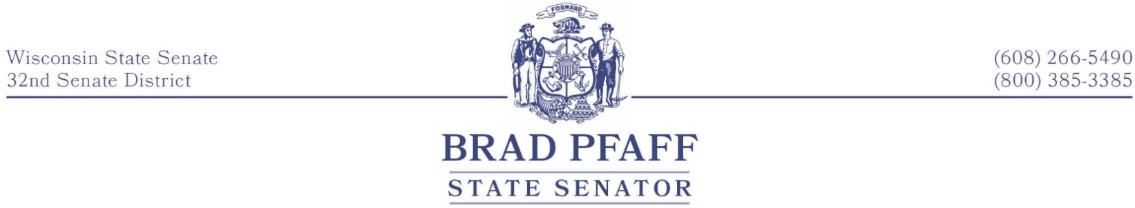

**FOR IMMEDIATE RELEASE**

**DATE:** July 2, 2025

**CONTACT**: [Sen Pfaff](mailto:sen.pfaff@legis.wi.gov), 608-266-5490

**Senator Pfaff Votes “Yes” on Bipartisan State Budget**

**Madison, WI –** Today, the Wisconsin State Senate passed the 2025-27 biennial budget with bipartisan support. Senator Brad Pfaff (D-Onalaska) voted in favor of the budget, which resulted from negotiations between Democratic and Republican legislative leaders and Governor Tony Evers. Sen. Brad Pfaff released the following statement:

“While this budget is far from perfect, it’s considerably better for our state than the budget that the majority party was considering just weeks ago, or no budget at all. After years of delay because of partisan politics, the Prairie Springs Science Center will finally get done. This is a big deal for the La Crosse community and economy, as well as Wisconsin’s ongoing workforce needs.

“Let me be clear, this is not the budget that I would have written, and it misses the mark in key areas, like public education. While the budget does make a historic investment in the state’s special education reimbursement rate, we could and should be doing more for our schools, kids, and teachers.”

**Notable items included in the passage of the final budget:**

**Prairie Springs Science Center**: $194 million for the completion of the Prairie Springs Science Center at UW-La Crosse and the demolition of outdated Crowley Hall, enhancing STEM education and workforce development by providing modern instructional labs and research facilities.

**Targeted Income Tax Relief**: Reduce income taxes in Wisconsin by over $600 million annually. Most of the benefits, averaging $180 per filer, will go to 1.6 million working and middle-class taxpayers, with 82% of the relief going to those earning under $200,000.

**Child Care:** $330 million investment in child care, including direct payments for child care providers, a new “Get Kids Ready” initiative, and increased rates for the Wisconsin Shares Program.

**Special Education Reimbursement Increase:** Provide the largest increase in special education aid for K-12 schools ever in state history, increasing the rate to 42 percent in the first year of the biennium and 45 percent in the second year of the biennium.

**ARIP**: Invest $150 million in the Agricultural Roads Improvement Program (ARIP) to repair and upgrade rural roads, supporting farmers, producers, and the agricultural and forestry industries. Of that total, $30 million is dedicated to fixing deteriorating bridges and culverts.

**Energy Sales Tax Relief:** Eliminate the sales tax on household utility bills to reduce energy costs, saving Wisconsin households more than $178 million over the biennium.

*Senator Brad Pfaff represents the 32nd Senate District, which includes La Crosse County, Vernon County, and parts of Monroe and Trempealeau County.*