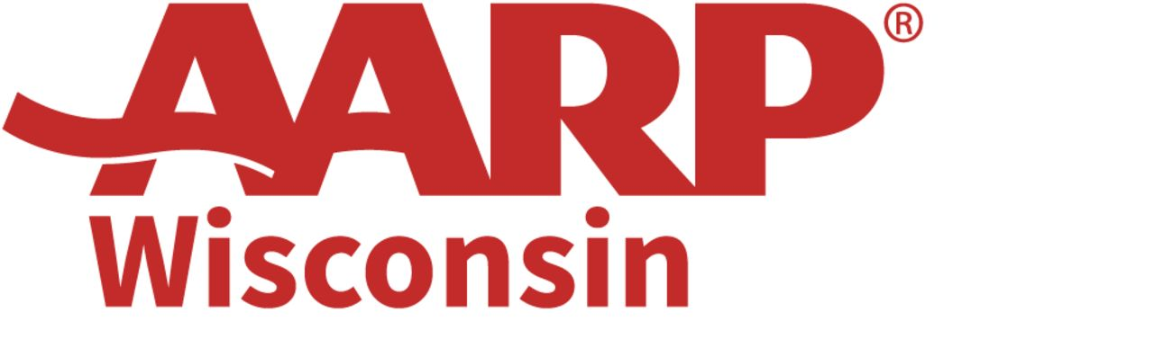

June 18, 2025 / FOR IMMEDIATE RELEASE
Contact: Jim Flaherty, Communications Director
Office 608/ 286-6308 – Cell 608/ 698-0928, jflaherty@aarp.org

Four Milwaukee projects win AARP grants aimed at making the city more livable for all residents as they age

Grants will help residents improve how they live, move, and stay connected through innovative projects

MADISON, WI – AARP today announced that 11 projects in eight Wisconsin cities – including four separate projects in Milwaukee – will receive 2025 AARP Community Challenge grants totaling a combined $103,500.

Other cities with grant-winning projects include Appleton, Darlington, Green Bay, Ladysmith, Madison, Neillsville, and Sturgeon Bay (Door County). The grants are part of AARP’s $4.2 million commitment to fund 383 quick-action projects aimed at making communities more livable for people of all ages, with a focus on the needs of older adults. The funds will support efforts to improve public places, transportation, housing, digital connections, and other key areas.

“AARP Wisconsin is proud to work with communities across the state to help make them more livable for people of all ages,” said AARP Wisconsin State Director Martha Cranley. “These projects are about turning great local ideas into real improvements that make everyday life better, especially for older Wisconsinites.

Here are the details of the four Milwaukee projects that will receive grants…

--The Humbolt Park Friends will receive a $2,500 grant to conduct six walk audits near Humboldt Park to identify improvements in lighting, walkways, crosswalks, and seating. The project will recruit 20 or more older volunteers and present findings to residents, county park personnel, and city and county officials to discuss incorporating results into municipal and park planning.

--The Jackson Park Community Association will receive a $2,500 grant to conduct four walk audits on streets leading to Jackson Park to promote better health and increase walking among older and younger populations. Neighbors will audit, assess, and propose solutions with city and county officials. The project will conclude with a community-wide gathering for feedback.

--Mujeres con Poder de Transformación Social will receive a $15,000 grant to improve Kozy Park's infrastructure with increased seating, better lighting, and native landscaping. This project aims to enhance accessibility and usage, especially for residents age 50-plus.

--Congress for the New Urbanism Wisconsin will receive a $2,500 grant for residents to conduct 4-6 transit-oriented walk audits in three neighborhoods with congregate housing for older adults of varying socio-economic status. Activities include the audit, bus training, civic engagement coaching, and follow-up.

Other Wisconsin projects include:

Appleton – The Friends of the Appleton Fire Department will receive a $2,500 grant to provide emergency preparedness guidance from the City of Appleton Fire Department and Emergency Management staff to two assisted living facilities. Using disaster preparedness guides and essential supply kits, sessions will allow residents to ask questions and collaborate with experts to improve preparedness kits.

Darlington – The Johnson Public Library will receive a $1,500 grant to create a Seed Library to promote seed saving, distribution, and sustainability. It will offer educational programs, starter seeds, and community events, benefiting all ages, especially those age 50 and over, by fostering gardening skills and community engagement.

Green Bay – New North, a non-profit organization based in Green Bay, will receive a $20,000 grant for its NEW BOOST project, which will expand digital access and literacy in the northeast region by training community navigators. This initiative will help residents, especially those age 50-plus, adopt and use internet services, reducing isolation and improving access to essential services.

Ladysmith – The Rusk County Community Library Foundation will receive a $10,000 grant to replace outdated handicap door openers at the library to ensure safe and independent access for all patrons, including those with disabilities and older adults. This project will enhance accessibility, comply with ADA standards, and encourage community engagement.

Madison – REALTORS Association of South Central Wisconsin will receive a $20,000 grant to host an Accessory Dwelling Unit (ADU) design competition to create affordable housing for older adults in Madison. The competition will focus on accessibility, sustainability, and affordability. Winning designs will be showcased and made available to residents, promoting innovative housing solutions.

Neillsville – The Neillsville Improvement Corporation will receive a $7,000 grant to transform a brushy area next to the community walking trail into a creekside greenspace with an accessible picnic table, bench, and pathway. Volunteers will clear the brush, grade the area, and install ADA-compliant amenities for all residents to enjoy.

Sturgeon Bay – Door County Habitat for Humanity will receive a $20,000 grant for a program that will offer free repairs to homeowners age 50-plus in Door County, ensuring they can age in place safely. Volunteers will fix handrails, stairs, faucets, toilets, windows, and doors, funded by grants for materials. The program targets veterans and people with disabilities.

“AARP Community Challenge projects may be quick to launch, but their impact is long-lasting,” said Nancy A. LeaMond, AARP Executive Vice President and Chief Advocacy & Engagement Officer. “We’re proud to support communities nationwide to advance solutions that make neighborhoods and towns of all sizes better places to live where everyone can thrive. And this year, we’re particularly proud to invest in projects benefitting often overlooked rural areas.”

The grant program is part of AARP’s nationwide Livable Communities initiative, which supports the efforts of cities, towns, neighborhoods and rural areas to become great places to live for people of all ages, with an emphasis on people ages 50 and older. Grant projects will be funded in all 50 states, Washington, D.C., Puerto Rico, and the U.S. Virgin Islands.

View the full list of grantees/projects at aarp.org/communitychallenge. Learn more about AARP’s work to support livable communities at aarp.org/livable.

# # #

AARP is a nonprofit, nonpartisan organization, with a membership of more than 37 million, that helps people turn their goals and dreams into real possibilities, strengthens communities and fights for the issues that matter most to families such as healthcare, employment security and retirement planning. We advocate for consumers in the marketplace by selecting products and services of high quality and value to carry the AARP name as well as help our members obtain discounts on a wide range of products, travel, and services. A trusted source for lifestyle tips, news and educational information, AARP produces AARP The Magazine, the world's largest circulation magazine; AARP Bulletin; www. aarp.org; AARP TV & Radio; AARP Books; and AARP VIVA, a bilingual news source. AARP does not endorse candidates for public office or make contributions to political campaigns or candidates. The AARP Foundation is an affiliated charity that provides security, protection, and empowerment to older persons in need with support from thousands of volunteers, donors, and sponsors. AARP has staffed offices in all 50 states, the District of Columbia, Puerto Rico, and the U.S. Virgin Islands. Learn more at www.aarp.org.

