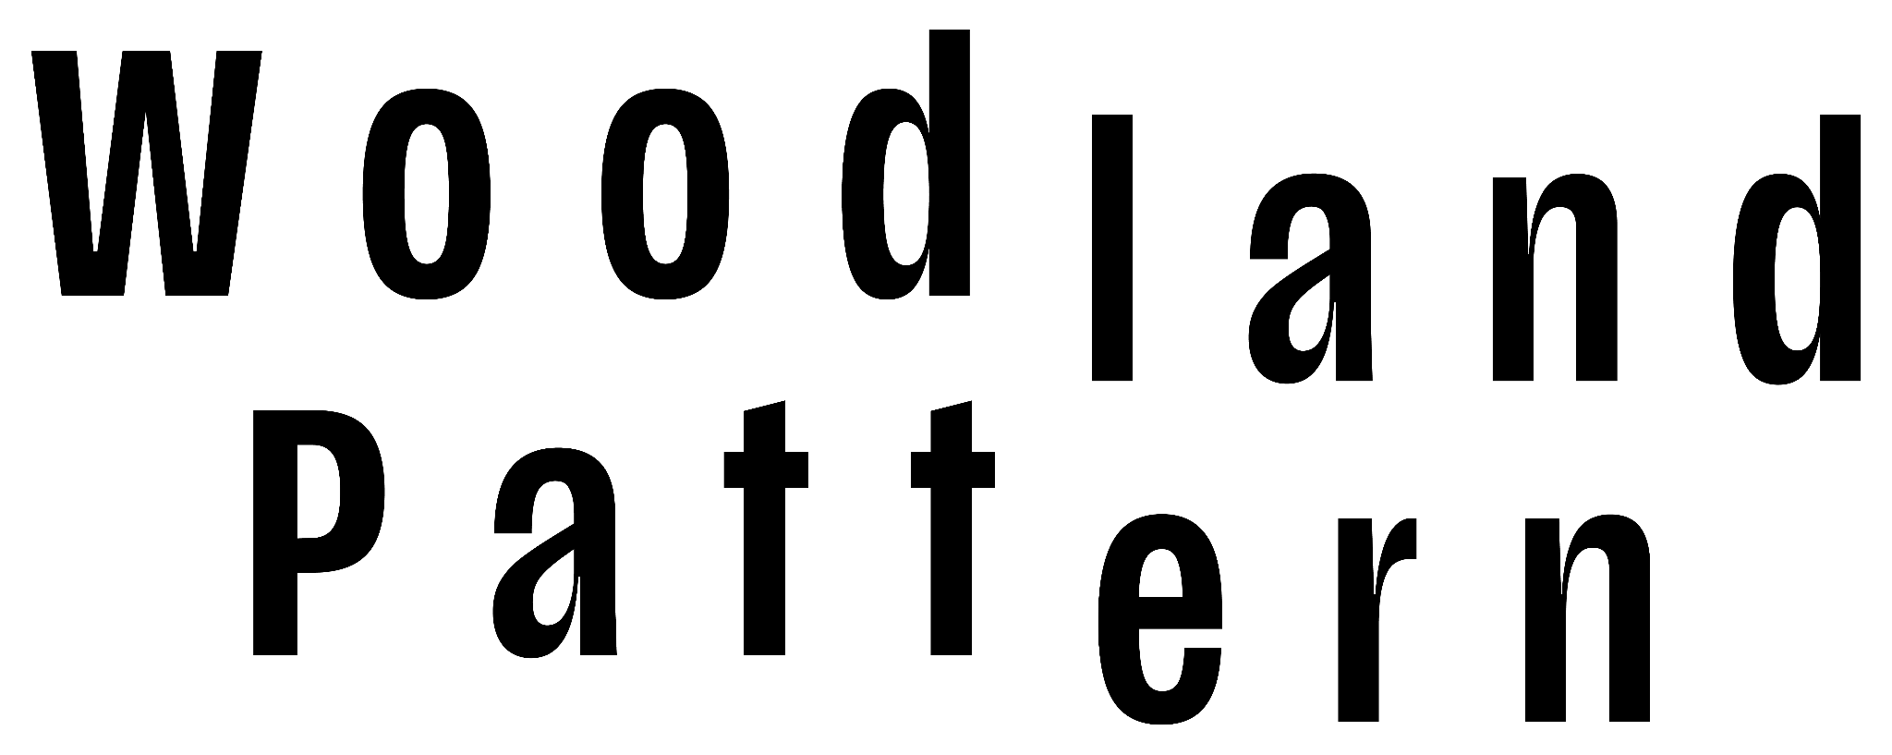

**FOR IMMEDIATE RELEASE**

**June 4th, 2025**

**Media Contacts:**

**Michael Wendt, Programming Director**

**(414) 263-5001**

**info@woodlandpattern.org**

**Poetry in the Park Returns for Its 11th Season**

Milwaukee, WI (May 30, 2025)—Woodland Pattern, a literary arts organization in Riverwest, will present the eleventh season of Poetry in the Park this summer at Juneau Park (900 N. Prospect Ave). Readings will take place beginning at 6:30 pm on the second Tuesday of each month from June–September (June 10, July 8, August 12, and September 9). The rain date for each reading will be the second Wednesday of the month.

Each of these readings will feature four regional poets, and take place at the south end of the park near the statue of Solomon Juneau, and just steps away from the Juneau Beer Garden. Bring your blankets and chairs, snacks and drinks, and friends, and join us in celebrating more than a decade of poetry in a beautiful outdoor setting!

The 2025 season will kick off on [**Tuesday, June 10**](https://woodlandpattern.org/events/poetry-in-the-park-june-2025), with a reading featuring **Ed Werstein**, who served on the Wisconsin Fellowship of Poets Board as East Region VP for more than a decade; **Freesia McKee**, who is the author of three chapbooks and teaches in the English Department at the University of Wisconsin–Stevens Point; **Margot Armbruster**, a Milwaukee-based writer and editor who studied at the Iowa Young Writers’ Studio; and **John Contreras**, who is Manager for Sociocultural Programming in Student Involvement at UW–Milwaukee, and who offers personalized typewriter poetry for events and runs typewriting workshops throughout Milwaukee.

On [**Tuesday, July 8**](https://woodlandpattern.org/events/poetry-in-the-park-july-2025), we’ll welcome four regional poets laureate or finalists for regional laureateships: Wisconsin Poet Laureate, **Brenda Cárdenas**, who has also served as Milwaukee’s Poet Laureate and is Professor Emerita of English at UW–Milwaukee; Milwaukee Poet Laureate, **Shelly Conley**, a seven-time member of Milwaukee’s National Poetry Slam Team who serves as Program Director and Co-Facilitator for My Sista’s KeepHer (MSK); Kenosha Poet Laureate, **Nico Moore**, a poet, spoken word artist, and musician; and Milwaukee Youth Poet Laureate Finalist, **Ilysium Nollie**, a junior at Tenor High School in Milwaukee.

The [**Tuesday, August 12**](https://woodlandpattern.org/events/poetry-in-the-park-aug-2025), reading will feature **Tacey M. Atsitty**, Assistant Professor of Creative Writing at Beloit College, whose book, *(At) Wrist*, won the Brittingham Prize in Poetry from the University of Wisconsin–Madison; **Gnat Bowden**, an artist and writer working across multiple media; **Ian Izard**, a writer and illustrator whose illustrated artist books have been shown at UWM’s Peck School of the Arts and at MIAD; and Chicago-based poet, union representative, and author of the forthcoming book, *Once Upon a Riot*, **Dawn Tefft**.

The 2025 season will conclude on [**Tuesday, September 9**](https://woodlandpattern.org/events/poetry-in-the-park-sept-2025), with readings from four Madison-based poets, including **Alexandria Delcourt**, who runs the Isthmus Writing Workshops, and is the Editor for *Our Lives Magazine*; **Andy Gricevich**, poet, musician, and founder of What Got Gathered, which offers foraging education and makes food products highlighting wild ingredients; **Steve Timm**, sound poet and author of several books of poetry, including *Ornithocracy* (Stone Corpse Press, 2024); and **Anada Werner**, a bookseller and poet whose debut chapbook, *Punt*, was published by Ugly Duckling Presse in 2024.

This beloved summer reading series was founded in 2014 by Sandy Duffy, poet and then–Vice President of Juneau Park Friends, and was run by Duffy, along with Lindsay Daigle and Franklin K.R. Cline, for five years. In late 2019 the series was handed off to Woodland Pattern, who’ve had the privilege of hosting Poetry in the Park ever since, with generous continued support from the Juneau Park Friends.

**About Woodland Pattern Book Center:** Woodland Pattern is a nonprofit book center, gallery, and performance space supporting the work of poets and other artists from Milwaukee and around the country. Each year, the organization hosts 400+ programs and events—including workshops, poetry performances, concerts, exhibitions, films screenings, and programs for children and youth. Since 1980, the organization has presented a long list of seminal figures in contemporary literature, music, film, and art, while also serving as a community space.

In addition to its programmatic activities, Woodland Pattern houses over 25,000 small-press titles otherwise unavailable in the Milwaukee area and is home to the largest collection of haiku in North America, the largest Native American section in Wisconsin, and one of the largest collections of contemporary poetry in the world. The center likewise holds a sizeable collection of works by writers from Wisconsin and the Upper Midwest, including hundreds of self-published books.