**Garden Club of Greater Milwaukee**

Milwaukee, WI

PRESS RELEASE

Contact:

Debra Koenig, Open Days Chair

GardenClubGreaterMilwaukee.org

debra.s.koenig@gmail.com

FOR IMMEDIATE RELEASE

Garden tour season is here! Do not miss a chance to see five spectacular private gardens in the Washington Highlands. Open Days: Saturday, July 19th and Sunday July 20th, 10 AM - 4 PM. Also available is a guided, 90-minute walking tour of the landscape and residential architecture of the Washington Highlands as part of the Digging Deeper program.

**May 2025 Milwaukee, WI** The Garden Club of Greater Milwaukee (GCGM), in partnership with The Garden Conservancy, will host Open Days at five unique private gardens located in the Washington Highlands in Wauwatosa. Also on offer, under the banner of The Garden Conservancy’s Digging Deeper Program, is a 90-minute walking tour focused on the history of this iconic area – “Washington Highlands: Where Beer Barons, Prohibition and Garden City Landscape Architecture Intersect”.

Open Days and Digging Deeper are programs of The Garden Conservancy, an acclaimed national organization dedicated to preserving, sharing, and celebrating America’s gardens and diverse gardening traditions for the education and inspiration of the public. This year’s Open Days gardens and Digging Deeper walking tour are located in the beautiful, historic Washington Highlands, a residential area in Wauwatosa, Wisconsin, directly west of Milwaukee. Washington Highlands is known for its unique, stately homes and lovingly-tended gardens. The participating gardens range from ¼ acre to ½ acre in size and are within easy walking distance of each other. Visitors will enjoy visiting all five of these uniquely diverse gardens, walking this charming neighborhood, and learning more about the neighborhood’s rich history.

Visitors may see all five Open Days gardens by purchasing three tickets – one for Serendipity Terraces and Ann’s Garden, one for Casa Alta Vista and Austermann Garden, and one for Rooms with a View for a total of $15 for Garden Conservancy members and $30 for the general public. Advanced purchase is required; tickets for either Saturday, the 19th or Sunday, the 20th, are timed (10:00-12:00, 12:00-2:00, 2:00-4:00) and are limited, *so purchase early to get your preferred time slot*. Children 12 and under are admitted free with paid adult admission. Advance purchase is also required for the Digging Deeper walking tour, with timed tickets for 10 AM or 2 PM on either Saturday or Sunday at a cost of $30 for Garden Conservancy members or $40 per person for the general public. Digging Deeper tickets are more limited than Open Days tickets, so please purchase early to avoid disappointment. Tickets are currently available by following the ticket sales link at the Garden Club of Greater Milwaukee website <https://gardenclubgreatermilwaukee.org/open-days-2025> or by visiting the Garden Conservancy website, <https://gardenconservancy.org/garden-directory/open-days?location=wisconsin>

“The gardens featured in the Highlands are true treasures,” according to Debra Koenig, Open Days Chair for GCGM and Regional Ambassador for The Garden Conservancy’s Open Days program. “Each has an abundance of diverse features to offer.”

- More -

- 2 -

Garden Club of Greater Milwaukee - Open Days

**Austermann Garden** Perched at the highest point in the Washington Highlands, the Austermann Garden has evolved as the now 100-year-old tree canopy of the north yard has cast much of the property in deep shade. That hasn’t stopped the owners from creating a dramatic pathway edged with Annabelle hydrangeas that draws the visitor into the shady environs of towering Chinese elms underplanted with beds of shade-loving perennials interspersed with sculptures and fun art pieces. Taking advantage of sunny spots in the south and front yards, the owners have a collection of over 30 varieties of day lilies and colorful porch pots filled with topicals and bold annuals, as well as climbing vines.

**Casa Alta Vista** This Mediterranean style home, on the National Register of Historic Places, contains a pastiche of dramatic accents including outdoor staircases, archways, niches, inlaid terra cotta panels, brick patterning and a tile roof. Its counterpoint is a peaceful yard that is mostly in deep shade from the

100-year-old tree canopy. The owners have invested in stone walls and pathways, improved an existing water feature, and introduced color, shape and texture through pots filled with begonias and other tender shade plants to bring interest and energy to this oasis that seems a world apart from Wisconsin.

**Ann’s Garden** If "variety is the spice of life," one would call this a spicy garden. At last count, it includes over 30 varieties of trees and shrubs, and over 100 different ground covers, perennials, and native plants. The garden is now a certified wildlife habitat. Since retiring, Ann has discovered a new passion – ART! Now a docent at the Milwaukee Art Museum, Ann has combined both collecting and creating art with her love of gardening. She especially enjoys using natural materials and displays her art throughout the garden.

**Serendipity Terrace** The owners of this property had limited gardening space until 1984, when they had the opportunity to purchase the house, with a much larger lot above them. After reselling the house (with a reduced yard), they were left with a large, relatively flat upper garden which could be connected with the existing yard through a series of stone terraces, paths and stairs. All of a sudden they had lots of interesting spaces on which to garden. See how this stroke of luck has led them to a series of 3-season gardens which are indeed serendipitous! They continue to evolve as the owners discover irresistible plants that give them new ideas to further enrich a visitor’s experience – more serendipity!

**Rooms With a View** Built in 1926, this Germanic, cottage-style residence was the model home of the Washington Highlands in Wauwatosa, Wisconsin – both the house and neighborhood are on the National Historic Register. For the past 27 years the home has served as a beautiful backdrop to an evolving garden oasis, which has been transformed from a steep hill into a terraced garden filled with diverse plant life and themed areas. Among the highlights are gardens centered on a state-champion, 100-year-old ginkgo, a state-champion copper beech, a potager-style vegetable garden and a colorful front-yard border.

- More -

- 3 -

Garden Club of Greater Milwaukee - Open Days

“The Digging Deeper historic walking tour of the Washington Highlands will be a revelation, even to long-time residents of the greater Milwaukee area,” according to Debra Koenig, Open Days Chair for GCGM and Regional Ambassador for The Garden Conservancy’s Open Days program. “Members of our Garden Club have taken this tour, and uniformly had high praise for the experience.”

The Garden Club of Greater Milwaukee has been hosting Open Days in the Greater Milwaukee Area since 2021. The Garden Conservancy has high praise for the work the Club is doing. According to Horatio Joyce, Director of Programs & Education for The Garden Conservancy, “Some partners go above and beyond the ask. That’s the Garden Club of Greater Milwaukee. For them, it’s about telling a story and crafting an experience through the gardens they select. When partners reach this level, its impact on the local gardening scene is immense and not to be missed.”

The Garden Club of Greater Milwaukee, formerly the Milwaukee Art Museum Garden Club, was established over 100 years ago. As the largest and oldest garden club in Wisconsin, it continues its tradition of community outreach through a variety of volunteer and educational programs, including awarding $15,000 of scholarships annually for post-high school study of horticulture, landscape design and environmental fields including soil science and forestry.

- 4 -

Garden Club of Greater Milwaukee - Open Days

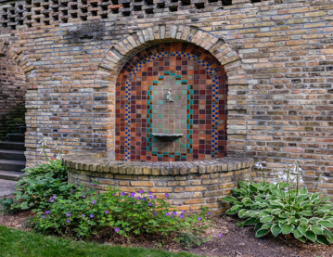

***Serendipity Terraces***

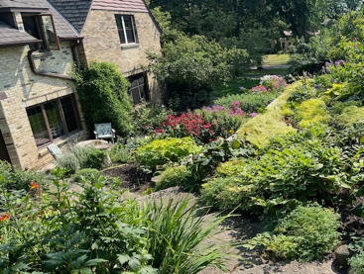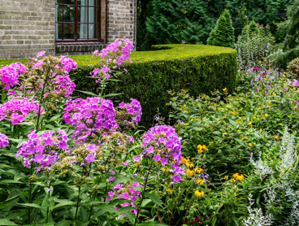

***Rooms with a View***

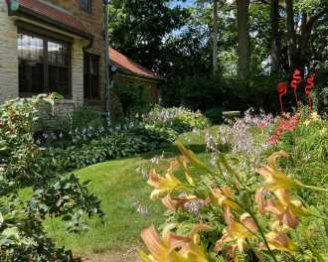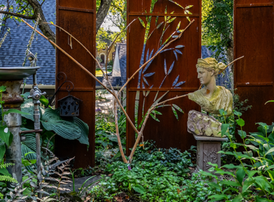

***Austermann Garden***

***Ann’s Garden***

***Casa Alta Vista***