FOR IMMEDIATE RELEASE

Melissa Scherrer Paré brings bold color and ephemeral beauty to MOWA | DTN
Material and memory are at the heart of the artist’s solo exhibition, Natural Selection

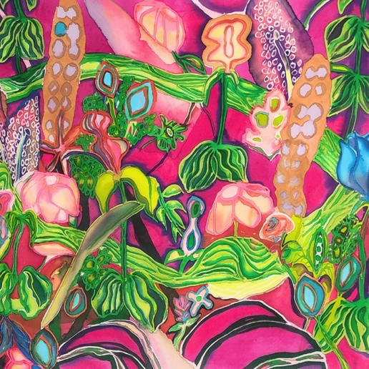
(Milwaukee, WI) Museum of Wisconsin Art is delighted to present Melissa Scherrer Paré: Natural Selection, on view at MOWA | DTN beginning June 6. In this exhibition, Paré creates ethereal silk paintings and textured paper pulp vessels that honor the beauty and complexity of the floral and geometric patterns remembered from the textiles of her childhood home. Together, these silks and vessels reflect a practice grounded in domestic materials and familial memory, where beauty is selected from daily life, shaped by hand, and reconfigured into arrangements of bold color, intuitive linework, and organic form. Natural Selection will be on view through August 31.

“Natural Selection showcases the trajectory of Paré's work over the last few years. Her silk paintings become more saturated with otherworldly pools of overlapping color, in some cases leaving no negative space at all, and the paper pulp vessels transitioned from nearly all-white to vibrant combinations of neon that command the eye's attention,” said Anwar Floyd-Pruitt, MOWA’s Associate Curator of Contemporary Art. “Paré keeps pushing herself and her materials to fantastic new heights, while keeping true to the intuitive creative process that drives her artistic practice—the results are stunning.”

Natural Selection transforms personal history and domestic remnants into works of quiet complexity and poetic form. Using a hot soy-wax batik technique on Japanese habotai silk, Paré paints layered, semi-abstract botanicals that drift across the surface like memories in motion. Her sculptural vessels are crafted of paper pulp—from shredded receipts, schoolwork, and medical records—molded over discarded containers.

“Viewers should expect a vibrant and cheerful assault of unexpected color combinations, shapes, and materials when entering the gallery,” said Dr. Jane Aspinwall, MOWA’s Deputy Director. “Paré creates an organic world related to reality but very much its own magical space.”

Paré received an MFA in photography from the University of Illinois–Chicago and a BFA from the University of Wisconsin–Milwaukee. Her work has been exhibited nationally and in Wisconsin, including the Wisconsin Museum of Quilts & Fiber Arts, the Villa Terrace Art Museum, and the Portrait Society Gallery.

In addition to the exhibition, MOWA will host an Opening Party on June 6 from 5:00–7:00 and an Artist Talk with Paré on June 12 at 6:00. Both events will take place at MOWA | DTN, inside Saint Kate–The Arts Hotel in downtown Milwaukee.

Join MOWA for Melissa Scherrer Paré: Natural Selection, an exhibition that invites viewers to consider how beauty emerges from overlooked places and personal history can be reimagined through exploration.
IMAGE CREDIT
Melissa Scherrer Paré, Reds, 2025

ABOUT THE MUSEUM OF WISCONSIN ART
A vital cultural center, educational institution, an expanding network of ideas, the Museum of Wisconsin Art (MOWA) collects and interprets American art through the lens of a single state. Informed by dynamic initiatives and collaborations, MOWA is an innovative forum for contemporary artists, socially relevant exhibitions, lectures by artists and industry experts, and engaging classes and activities for all ages.

MOWA has two permanent venues—the West Bend “Mothership” and MOWA | DTN in downtown Milwaukee’s Saint Kate—The Arts Hotel—as well as two partnering community organizations that create access across the state. MOWA annually welcomes 200,000 visitors, making it a cultural destination for the art and artists of our time.

wisconsinart.org
facebook.com/museumofwiart
instragram.com/museumofwiart
twitter.com/museumofwisconsinart
youtube.com/user/MuseumofWisconsinArt

MEDIA CONTACT
Isabel Sandretti
Marketing + Communications Specialist
262-247-2266 | isandretti@wisconsinart.org

