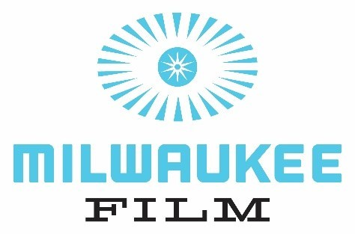

**FOR IMMEDIATE RELEASE Contact:** Robyn Ehrlich

Communications & Public Relations Coordinator

robyn@mkefilm.org

**The 2025 Milwaukee Film Festival Announces Award Winners**

*$24,000 in cash awards to be delivered to filmmakers near and far*

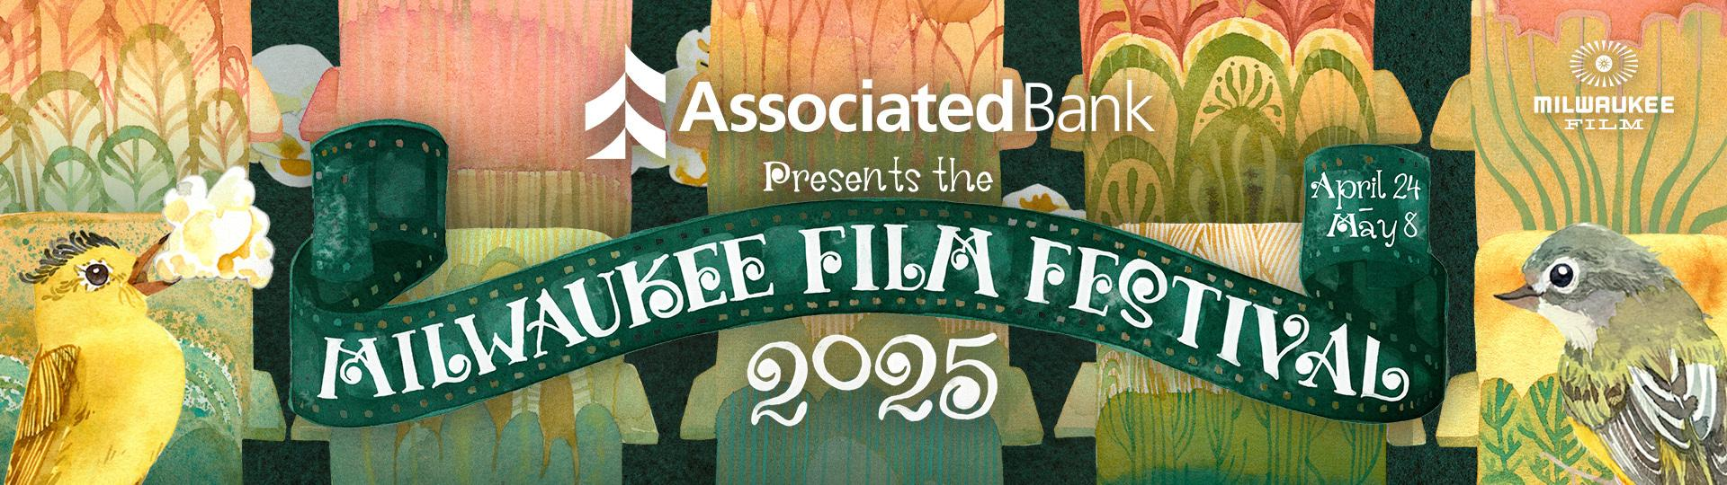

**MILWAUKEE – Wednesday, May 14th** – The 2025 Milwaukee Film Festival, presented by Associated Bank came to an end last Thursday, May 8th, and Milwaukee Film is honored to announce the winners of the 2025 Jury Awards, and reveal the 2025 Allan H. (Bud) and Suzanne L. Selig Audience Award Winners.

**MILWAUKEE FILM FESTIVAL BY THE NUMBERS**

Throughout the run of this 15-day festival, the energy and momentum were tangibly felt by audiences and the community at large, with attendance of 32,004 across the screenings and events on offer. The centralized East Side footprint of the Festival allowed for easier access to films without a trek across the city, an ease that is reflected in the growth of the average attendance at each screening of 47% over 2024’s averages.

Susan Kerns, Executive Director of Milwaukee Film, expressed, “This year’s Milwaukee Film Festival was two weeks of cinematic bliss. There’s something magical about the Film Festival—the crowds, the historic theatres, the mystery of what you’ll see next, and the sense that, for two hours, strangers are becoming a community, united by stories on the big screen.” She continued, “I have such immense gratitude that I get to be part of this and can help bring these experiences to the people of our city.”

**OVERALL**

**209 Films**: 97 feature films, including 49 documentary features and 48 fiction features, and 112 short films. 45% of feature films were directed by women or nonbinary filmmakers.

**$150,550** was raised through the 2025 Milwaukee Film Festival REEL Impact Drive, with the campaign being initially kicked off with a generous $10,000 donation from Susan and Robert Mikulay at the exclusive Festival Eve celebration event on April 23rd. This year, Milwaukee Film held its first online silent auction that ran throughout the 15-day Film Festival, including items such as original watercolor artwork from MFF25 campaign artist Jinjer Markley, garnering over $12,000. Additionally, Jim and Santha Kerns, parents of new executive director Susan Kerns, put forward a $3,000 match on the final day of the Festival, which was quickly met by our enthusiastic crowd of supporters. Milwaukee Film is beyond grateful for this community activation and support of our arts nonprofit organization allowing us to keep doing the work we do!

**ATTENDANCE**

**265** Public Screenings (and 3 Private Screenings, including our Super Secret Members-Only Screenings!)

**32,004 Total Attendance; over 30,000 at screenings alone**

**80 Filmmaker & Industry Guests** + countless local filmmakers

**2025 ABELE CATALYST AWARD**

The Abele Catalyst Award is presented annually by Milwaukee Film to a person or entity who has been catalytic to the organization. This year, the award was presented posthumously to Carmen and Bill Haberman on Opening Night of the 2025 Milwaukee Film Festival.

**2025 JURY AWARD WINNERS**

**Luminaries Jury Award - *Middletown*** (dirs. Jesse Moss, Amanda McBaine)

Special Mention: *Pavements* (dir. Alex Ross Perry)

Luminaries Jury:

Lela Meadow-Conner, Founder and CEO, mamafilm; Board President, Art House Convergence

Jourdain Searles, Writer and Critic

Amanda Keeler, Professor, Marquette University

**Emerging Fiction Jury Award - *Outerlands*** (dir. Elena Oxman)

Special Mentions: *Color Book* (dir. David Fortune)*, DJ Ahmet* (dir. Georgi Unkovski)

Emerging Fiction Jury:  
Rubin Whitmore, Filmmaker and Educator, University of Wisconsin - Milwaukee

Marian Masone, Curatorial Consultant

Allason Leitz, Principal, Third Industry Strategies

**Emerging Documentary Jury Award - *Remaining Native*** (dir. Paige Bethmann)

Special Mentions:*Life After* (dir. Reid Davenport), *A Mother Apart* (dir. Laurie Townshend)

Emerging Documentary Jury:

Cassidy Dimon, Executive Director, Filmmakers with Disabilities (FWD-Doc)

Cecilia R. Mejia, Impact Producer, VP of External Affairs for American Documentary | POV

Dinesh Sabu, Documentary Filmmaker and Educator, Marquette University

**Cream City Cinema Jury Award - *Zastava Brothers*** (dir. Pep Stojanovic)

**Cream City Cinema Jury Award - *What Happened to Dorothy Bell?*** (dir. Danny Villanueva Jr.)

**Cream City Cinema Jury Award - *CYCLE*** (dirs. Laura Dyan Kezman, William Howell)

Special Mentions: *Mandatory Bathroom Break* (dir. Alyssa Sue Borkowski), *One Minute Remaining* (dir. Colin Sytsma)*, MINE!* (dir. Lou Morton)

Cream City Cinema Jury:

Andrew Carlin, Co-Head of Theatrical Distribution, Variance Films

Alece Oxendine, Executive Director, Film Durham

Annalisa Shoemaker, founder and CEO, Suncatcher Productions

**Shorts Jury Award - *It Shouldn’t Rain Tomorrow*** (dir. Maria Trigo Teixeira)

Special Mention for Directing - Juan Vicente Manrique, *Looking for a Donkey*

Special Mention for Cinematography - Pablo García Gallego, *Ripe!*

Special Mention for Acting - Bonnie Hellman, *Susana*

Shorts Jury:

Mike Plante, Filmmaker and Programmer

Yinan Wang, Filmmaker and Educator, University of Wisconsin - Milwaukee

Amanda Salazar, Curator and Programmer, Director of Programming, Vidiots

**Kids’ Choice Jury Award - *The Carp and the Child*** (dirs. Morgane Simon and Arnaud Demuynck)

Special Mentions:

Most Inspirational - *Skate in the City* (dir. Lies van der Auwera)

Best Representation - *Unibrow* (dir. Nedda Sharshar)

Best Mixed Media Animation - *Hello Summer* (dir. Martin Smatana, Veronika Zacharová)

Best Message - *Dynasty and Destiny* (dir. Travis Lee Ratcliff)

The Kids’ Choice Jury Award is presented by a jury of 6 local youth ages ranging 9-12 annually.

**2025 AUDIENCE AWARD WINNERS**Attendees voted to determine the Allan H. (Bud) and Suzanne L. Selig Audience Awards. This year’s winning feature and short films were:

● Best Feature - ***The Librarians*** (dir. Kim A Snyder)

● Best Short - ***Jane Austen’s Period Drama*** (dirs. Julia Aks and Steve Pinder)

**DIALOGUES DOCUMENTARY FESTIVAL**

Last year, Milwaukee Film launched the first ever Dialogues Documentary Festival, 4 days dedicated solely to starting conversations utilizing the power of documentary. Milwaukee Film is thrilled to announce that the second Dialogues Documentary Festival will take place September 18-21, 2025.

**2026 MILWAUKEE FILM FESTIVAL DATES**

We are pleased to announce the dates for the 18th annual Milwaukee Film Festival–April 16-30, 2026. Mark them on your calendar now!

###

**About Milwaukee Film**

Milwaukee Film is a nonprofit arts organization dedicated to entertaining, educating, and engaging our community through cinematic experiences, with a vision to make Milwaukee a center for film culture. Milwaukee Film is committed to high-quality and accessible film programming through their operation of the magnificent Oriental Theatre, a historic cinema palace, and the iconic Downer Theatre, Milwaukee’s oldest running cinema. The second [Dialogues Documentary Festival](https://mkefilm.org/ddf-save-the-date) will take place September 18-21, 2025. The 18th annual [Milwaukee Film Festival](https://mkefilm.org/mff2025-save-the-date) will take place April 16-30, 2026. For more information or to become a Member, visit mkefilm.org.

 Milwaukee Film Board of Directors: [mkefilm.org/board](https://mkefilm.org/board)  Facebook: [facebook.com/MilwaukeeFilm](http://facebook.com/MilwaukeeFilm) | Twitter: [@mkefilm](https://twitter.com/mkefilm) | Instagram: [@mkefilm](https://www.instagram.com/mkefilm/)