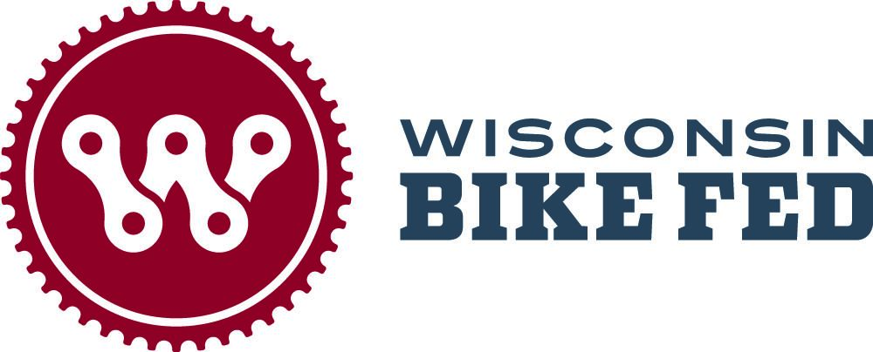

FOR IMMEDIATE RELEASE
May 13, 2025

CONTACT: Heather Rainer, Events Manager, Heather@wisconsinbikefed.org

Wisconsin Bike Fed Celebrates Wisconsin Bike Week
with Communities Across the State June 1 - 8, 2025

MILWAUKEE - The Wisconsin Bike Fed proudly announces Wisconsin Bike Week June 1-8, 2025.
This year we are delighted to present an exciting lineup of events and programs designed to educate, engage, and encourage cyclists of all ages and skill levels. Wisconsin Bike Week is a motivational, family-friendly celebration of cycling. Highlights include:
- Smart Cycling Classes: Covering everything from beginner basics to advanced techniques, with special tips for safe E-bike use.
- Crosswalk Action Training: Hands-on sessions to improve crosswalk safety for pedestrians and cyclists.
- Adult Learn-to-Ride Sessions: Perfect for adults who have never learned to ride and want to build confidence.
- Commuter Stations: These stations typically offer amenities and services aimed at making biking to work or other destinations more convenient, safe, and enjoyable.
In addition to in-person events, the Bike Fed will distribute educational materials throughout the week. Communities will have access to refreshed pamphlets, downloadable PSAs, and artwork to help promote cycling safety and awareness. Yard signs promoting ‘Give Cyclists 3 Feet’ are available for pick up at the Bike Fed offices in Milwaukee and Madison.
Wisconsin Bike Week is hosted by the Wisconsin Bike Fed. Scheduled events can be found on the Bike Fed’s Bike Week page.
For information on how to get involved with Bike Week and support the Bike Fed’s mission, visit wisconsinbikefed.org or contact the non-profit organization at 414-626-1540 and info@wisconsinbikefed.org.

Overview of Wisconsin Bike Week Activities (more added daily):

Ride with the Mayor: June 2, 2025 at 9:00am in Madison
Join us for a press conference with Madison Mayor Satya Rhodes-Conway and representatives from Bike Fed, Madison Bikes, City Transportation, and other dignitaries to kick off Madison Bike Week. Celebrate the accomplishments that make the city a great place to ride a bike as well as hear about plans for the future to keep moving forward.
After the press conference, join us for a quick spin around downtown.

Ride with the Mayor: June 5, 2025 at 8:30am in Milwaukee
Join the City of Milwaukee for the Mayor’s Bike Ride on Thursday, June 5. The five-mile, morning ride will begin and end at Burnham Park. Remarks from Mayor Cavalier Johnson will start at 8:30 a.m. and the ride will kick off shortly after. The five-mile ride will return to Burnham Park by 10 a.m.

Bike Fed Hosted Events: Madison Pride Ride - June 1
Family Learn to ride - June 2 (Madison)
Smart Cycling Basics - June 2 (Madison)
Family Learn to ride - June 3 (Madison)
Bike Month Kick-off party - June 3
Smart Cycling Basics - June 3 (Milwaukee, Spanish bilingual)
Adult Learn to Ride - June 4 (Milwaukee, Spanish bilingual)
Adult Learn to Ride - June 4 (Madison)
Smart Cycling Basics - June 5 (Milwaukee)
Smart Cycling Intermediate - June 6 (Madison)
Milwaukee Pride Ride - June 8
Ride to the Brewers Game - June 9 (Milwaukee)

Beloit: Stateline Spinners group ride - June 3
Eagle River: The Great Annual Bicycling Adventure - June 7-14
Eau Claire: Bike Chippewa Valley presents: Wisconsin Bike Week in Eau Claire
Fitchburg: Commuter Station - June 3
Rides for Joe - June 4
Franklin: Bike Rodeo - June 7
Green Lake: Green Lake 100 - June 7
Kenosha: Monday Night Stock Bike Racing - June 2
Track 101 - June 7
Madison: Madison Bikes presents: Madison Bike Week
Bike Bingo - Starts June 1
Old World Wisconsin Bike Tour - June 7-13
Milwaukee: UPAF Ride for the Arts - June 1
Bike Bingo - starts June 1
UEC Hank Aaron Bike Commuter Station - June 3-6
UEC Oak Leaf Bike Commuter Station - June 3-6
Bike to work morning meet up at ThriveOn King - June 4
Ad Rock/Bike Body Waffle Party - June 5
UEC Bike to the Beach Clean Up - June 5
Promise Zone Bike Ride - June 7

Middleton: Body Maintenance for Mountain Biking - June 7
Ringle: Ironbull Essential Gravel - May 30-June 15
St. Germain: Vilas 2025 Bike Rodeo - June 7
Waterloo: Trek 100 - June 7
Wilmot: BCLC Ramble Ride - June 8
Whitewater: Teen Trail Corps workday - June 7

Race Events: Cambridge: Battle of Camrock - June 1
Kansasville:WBR Single Bong TT - June 1
Kenosha: Stock Bike Racing - June 2
Cable: Epic Bike Fest - June 6-8
Deerbrook: Jack Lake Crazy Eights - June 7

About the Wisconsin Bike Fed
The Bicycle Federation of Wisconsin Educational Foundation, Inc. (AKA Wisconsin Bike Fed) was established as a 501(c)3 non-profit organization in 1988 to cultivate, motivate, and unite residents, communities, businesses, and political leaders to move bicycling forward in Wisconsin through education, legislation, and involvement. For 37 years the Bike Fed has been the only statewide organization that advocates for better bicycling for everyone who rides a bike in Wisconsin.

# # #

