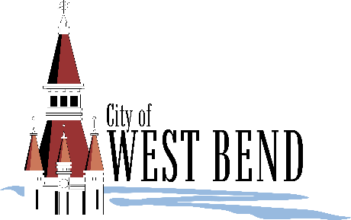

City of West Bend

1115 South Main Street

West Bend, WI 53095

**Media Contact:**

Jacob Moeller, Communications Coordinator

(262) 808-8926   
moellerj@westbendwi.gov

**FOR IMMEDIATE RELEASE**

**City of West Bend Welcomes   
Communications Director Kali Thiel**

**West Bend, Wis. (April 16, 2025):** The City of West Bend is pleased to announce the hiring of Kali Thiel as its new Communications Director.

“Kali’s extensive experience in communications and media relations makes her a great fit for this role,” said Interim City Administrator Tim Dehring, “Her track record demonstrates an ability to effectively and creatively communicate across various media. We are excited to welcome her to the City of West Bend!”

Thiel has almost two decades of communication, journalism, and marketing experience, most recently as Director of University Communications at Concordia University Wisconsin from 2015 to 2025. In her time at Concordia, she led a team in the oversight and production of social media, media outreach, and content strategy on behalf of the university. She also served as editor and lead author of the school’s alumni and stakeholder magazine, earning a Council for Advancement and Support of Education (CASE) award in 2019. Prior to Concordia, she was a reporter with Gannett Media. Within her time covering school and city government, she earned a first-place award from the Wisconsin Newspaper Association (WNA) Foundation Better Newspaper Contest.

“I am honored to receive this role and eager to begin exploring West Bend through fresh eyes,” Thiel said. “I look forward to collaborating with city leaders and staff to ensure open and effective communication that reflects the city’s goals, values, and unique pride points. Everything I have learned about West Bend so far assures me it is an incredibly special place to live, work, and visit.”

As Communication Director, Thiel is responsible for West Bend Community Television, Visit West Bend (tourism promotion and tourism development), and internal and external communications strategies for the city organization.

###

**About the City of West Bend**   
West Bend is 30 minutes north of Milwaukee in Washington County—a commercial center and industrial hub situated along the Milwaukee River in the heart of the Kettle Moraine. More than 32,000 people reside in the city and have access to numerous cultural and historical attractions, award-winning parks, quality healthcare, and exceptional educational opportunities. West Bend has a charming historic downtown with thriving businesses, shops, and restaurants, and several business and industrial parks poised for growth. For more information, visit westbendwi.gov.