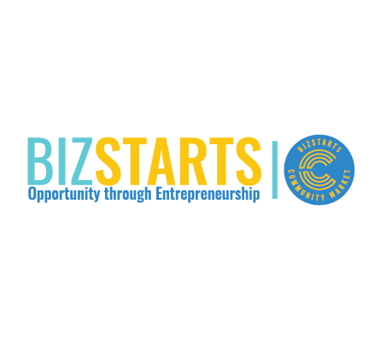

**FOR IMMEDIATE RELEASE**

**Media Contact:**Lily Dysart

Sr Director of Operations

[ldysart@bizstarts.com](mailto:ldysart@bizstarts.com)

414-973-2334 EXT 3

**BizStarts Wins International Recognition for Inclusive Entrepreneurship Leadership**

**Milwaukee, WI – April 10, 2025** — BizStarts Milwaukee is proud to announce that its President, **Patrick Snyder**, has been awarded the **2025 Julius Morgan Diversity & Inclusion Award** by the **International Business Innovation Association (InBIA)**. This international honor recognizes BizStarts’ leadership in building inclusive entrepreneurial ecosystems that uplift underrepresented founders—and puts Milwaukee on the map as a global model for equitable innovation.

The award is one of four **InBIA Specialty Awards**, which are presented annually to Entrepreneur Support Organizations (ESOs) around the world for excellence in innovation, impact, and inclusion. Named after NBIA co-founder Julius Morgan, the Diversity & Inclusion Award honors organizations that are breaking down barriers and championing access to opportunity in their communities.

“This recognition belongs to every entrepreneur in our community who’s ever been told ‘no’—and kept going,” said Snyder. “At BizStarts, we believe in building a better future by investing in the dreams of those who shape our neighborhoods, culture, and economy. This award affirms that the work we’re doing here in Milwaukee resonates on a global scale.”

BizStarts’ inclusive approach includes:

* **The BizStarts Institute**, a business bootcamp with mentorship and long-term support;
* **The BizStarts Community Market**, a Walkers Point hub for local vendors, networking, community events and a delicious cup of coffee;
* **First Launch**, a youth entrepreneurship initiative focused on underserved middle school students;
* And a growing ecosystem of partners dedicated to building generational wealth through entrepreneurship.

“These awardees represent the broad scope of what excellence in entrepreneurship support looks like today—from global reach to community impact, from digital storytelling to inclusive leadership,” said **Charles Ross, InBIA CEO**. “Their work continues to shape the future of innovation economies.”

BizStarts is honored to stand alongside this year’s global awardees from North Carolina, Indiana, and Arizona—and proud to represent **Milwaukee** as a leader in inclusive economic development.

For more information about BizStarts’ programs or to get involved, visit [www.bizstarts.com](http://www.bizstarts.com).

###

*About BizStarts*

*BizStarts brings entrepreneurs together from all backgrounds, ethnicities and beliefs to create a collaborative learning environment that embodies positivity, inspires confidence and develops people’s capacity to achieve personal success and business growth. Working together, we are creating economic opportunity, communities with unique character and a vibrant city with prosperity for all.*