**March 31, 2025**

International Transgender Day of Visibility

The City of Milwaukee Common Council proudly recognizes and celebrates International Transgender Day of Visibility, March 31, 2025. Today, we honor the achievements, resilience, and contributions of transgender, non-binary, and gender-diverse individuals while reaffirming our commitment to inclusivity and equality.

International Transgender Day of Visibility is a time to uplift and empower transgender, non-binary, and gender-expansive people, acknowledging both their successes and the ongoing challenges they face. We recognize that discrimination, misinformation, and violence continue to impact transgender and non-binary communities worldwide. While we celebrate those who can live openly, we also stand with those who may not yet feel safe to do so.

In the City of Milwaukee, we believe in fostering a workplace and community where everyone is seen, respected, and supported. As allies, advocacy must be more than a statement—it must be action. That means standing against hate, misinformation, and policies that harm transgender and non-binary people while amplifying their voices and experiences.

To all of our transgender, non-binary, and gender-diverse colleagues: You are seen, you are valued, and you are supported.

To our allies: We encourage you to continue learning, advocating, and taking meaningful steps toward equity and inclusion. Together, we can create a world where everyone has the freedom and safety to live as their authentic selves.

**NOTE**: Alders Zamarripa and Burgelis are the first two out LGBTQ+ Common Council members.

#TransDayOfVisibility #YouAreSeen #InclusionMatters

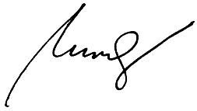  
Peter Burgelis  
Alderman, District 11

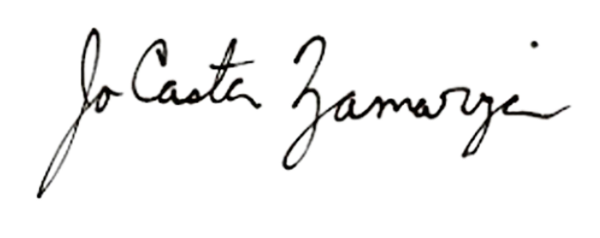  
JoCasta Zamarripa

Alderperson, District 8