[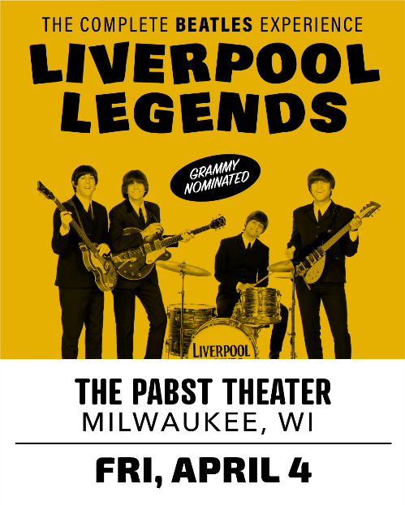](https://www.liverpoollegends.com)

*For Immediate Release*

Louise Harrison Presents…

**Liverpool Legends**

**“The Complete Beatles Experience!”**

**Media and Interview Requests: Contact Sarah Vargo at** [**sarah@sarahstargo.com**](mailto:sarah@sarahstargo.com) **or 224-622-1759**

**Date and Time: Friday, April 4, 2025 at 8:00pm.**

**Place:** The **Pabst Theater** | **144 East Wells Street, Milwaukee, WI 53203**

**Purchase tickets** [**HERE**](https://www.pabsttheatergroup.com/events/detail/liverpool-legends-2025) **or call Box Office at 414-242-8200. Ticket prices $34.50 - $80.00.**

Grammy-nominated and internationally acclaimed Liverpool Legends will be at The Pabst Theater on Friday, April 4, 2025, at 8:00pm.

Liverpool Legends are four talented musicians and actors, handpicked by Louise Harrison – sister of George Harrison, to honor her brother’s legacy and re-create the band that changed the world forever. Experience the complete history of The Beatles, starting with the early mop-top hits, such as I Want To Hold Your Hand, She Loves You and Twist and Shout. You’ll then take a Magical Mystery Tour down Penny Lane, through the psychedelic era of Sgt. Pepper. And in The End, Come Together and sing and dance to classics like Get Back, Here Comes the Sun and Hey Jude.

This one-of-a-kind Beatles show is narrated by Louise Harrison, and she was an instrumental part of the promotion of The Beatles in the early years. With precise attention to every musical detail, along with costume changes, vintage instruments and special effects, Liverpool Legends will make you feel like you are watching the real thing! Together, these four lads will bring you “The Complete Beatles Experience.”

Accomplishments for Liverpool Legends:

* Liverpool Legends was nominated for a Grammy Award for their work on "Fab Fan Memories" - a Beatles Bond.
* Liverpool Legends have toured all over the world with sold-out performances in The U.S., Mexico, India, Israel, Ukraine, and South America.
* Headlined the Rose Bowl in Pasadena, CA in front of 68,000.
* Received national attention when they re-created The Beatles famed 1966 concert at Busch Stadium in St. Louis.
* Headlined at the world-famous Carnegie Hall in New York City where The Beatles performed in 1964.
* Chosen over every other Beatles Tribute band in the world by top television and film producer Jerry Bruckheimer (CSI, Pirates of the Caribbean, National Treasure) to portray The Beatles.
* Performed at The Cavern Club in Liverpool and recorded at the famed Abbey Road Studios in London.
* Received the Travelers’ Choice Award by TripAdvisor in 2023, placing Liverpool Legends in the top 10% of attractions worldwide.

Many tribute acts recreate the sound and the harmonies of the Fab Four, but Liverpool Legends takes it one step further. All four band members have mastered the looks, mannerisms, and the thick Liverpool accent, that makes the experience totally authentic. In addition, Liverpool Legends seem to “possess” the personalities of John, George, Paul and Ringo, which make the lighthearted banter with the audience irresistible!

***“Hey, that’s you! I could spot John out anywhere! You make a great John!” – Paul McCartney***

***“Phenomenal in every way…it is pure magic!” – Jerry Bruckheimer***

***“It’s like shaking Mr. McCartney’s hand in person.” – Dick Biondi, legendary radio personality and first American DJ to play The Beatles record on the radio***

**LIVERPOOL LEGENDS online:**

[**WEBSITE**](http://www.liverpoollegends.com/)

[**FACEBOOK**](https://www.facebook.com/liverpoollegendsofficial/)

[**YOUTUBE**](https://www.youtube.com/@LiverpoolLegendsBeatles)

[**INSTAGRAM**](https://www.instagram.com/liverpoollegendsbeatles/?hl=en)

[**TIKTOK**](https://www.tiktok.com/@liverpoollegendsbeatles)

[**PROMOTIONAL VIDEO**](https://www.dropbox.com/scl/fi/bjy25vl6qardzgvzl2xgz/liverpool-legends-louise-promo-spot-hd-1080p.MOV?rlkey=im5ar5gr0vvg83g9jfia680q8&st=ba608yo4&dl=0)

