**FOR IMMEDIATE RELEASE**

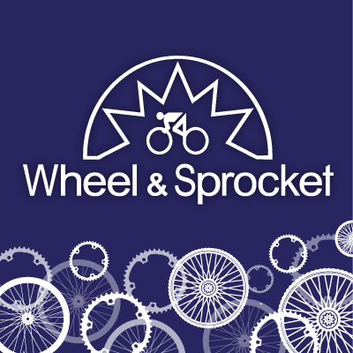 **PRESS RELEASE**

**MEDIA CONTACT:**Tessa Kegel

Marketing Manager

[Wheel & Sprocket](https://www.wheelandsprocket.com/)

**Wheel & Sprocket Celebrates Biking & Community at the Nation's Largest Bike Sale - Back for the First Time Since 2019**

*Electric Bike Test Track, Hundreds of Used Bikes, Discounted Brand New Bikes, and over 50 Community Riding Groups with Speakers and Seminars, Come Together at the Wisconsin State Fair Park Exposition Center*

**Milwaukee, WI – (3/18/2025)** –Wheel & Sprocket’s Annual Bike Expo Sale, a mainstay to the start of spring and the outdoor biking season in the Upper Midwest, is back for the first time since Covid. The sale runs **Friday, April 11 - Sunday, April 13 at Wisconsin’s State Fair Exposion Center, West Allis**. Biking is becoming increasingly more popular because of the game-changing electric bike (e-bikes), recent studies on health benefits, interest in sustainable transportation, and improvements in infrastructure.

Bike Expo Sale includes over **2,000 bicycles (including hundreds of used bikes & electric bikes)**, bike accessories, community speakers and seminars, and over 50 riding groups for every type of rider. **New this year will be the availability of over two hundred adult and kids’ Used Bikes.** Staff from **Wheel & Sprocket, Trek, Electra and major bike related brands** will be guiding customers to help with their riding needs. Times are:

**Friday 12-8pm**

**Saturday 10am-8pm**

**Sunday 11am-5pm**

***Try an Electric Bike on the Test Track:***  Wheel & Sprocket continues to expand E-Bikes. Equipped with pedal-assist motors and chargeable batteries, electric bikes have become popular world-wide, allowing for longer rides and more possibilities. Try one out on our E-Bike Test Track to learn what the buzz is about.

***NEW Used Bikes for Purchase:***  Hundreds of reasonably priced used bikes ranging from kids to top-of-the-line road bikes will be available at this year’s Expo. Every Wheel & Sprocket used bike goes through a stringent check and repair process, is professionally assembled and ready to ride.

***Trade In’s Accepted::*** Customers are encouraged to bring their used bike to trade-in towards a new bike at Expo.

***Community Groups:***  Bikes improve lives and create better, healthier communities. Bike Expo Sale is a great place to check out over 50 ride groups, trails organizations, cycling events and other ways to explore the region by bicycle.

***Best Time to Buy:*** Bike Expo Sale makes it easy to find the bike of your dreams with expert staff to guide customers to the right bike to enjoy the riding. Expo always offers the best prices of the season backed by 30-day satisfaction guarantee and 110% price protection.

More information on dates and times go to <https://www.bikeexposale.com/>

**ABOUT WHEEL & SPROCKET**

Since 1973, Wheel & Sprocket has been serving the community and has grown from its original Hales Corners, Wisconsin location to include a total of ten locations in Metro Milwaukee, Wisconsin’s Fox Valley, Madison, and Chicagoland. Wheel & Sprocket is family-owned and operated, and employs over 200 people who have a passion for bicycling. Over the years, Wheel & Sprocket has been recognized as one of the best independent bicycle retailers in the country and has been included as one of America’s Best Bike Shops for over two decades. Community action, engagement, and political advocacy is also an integral part of the company culture including support for over seventy bike events each year.