**MEDIA ALERT**

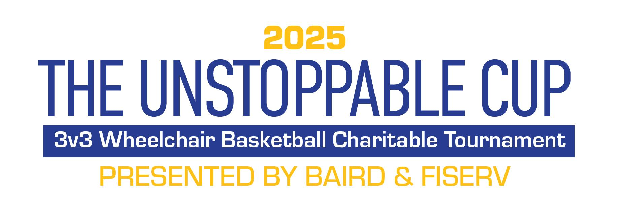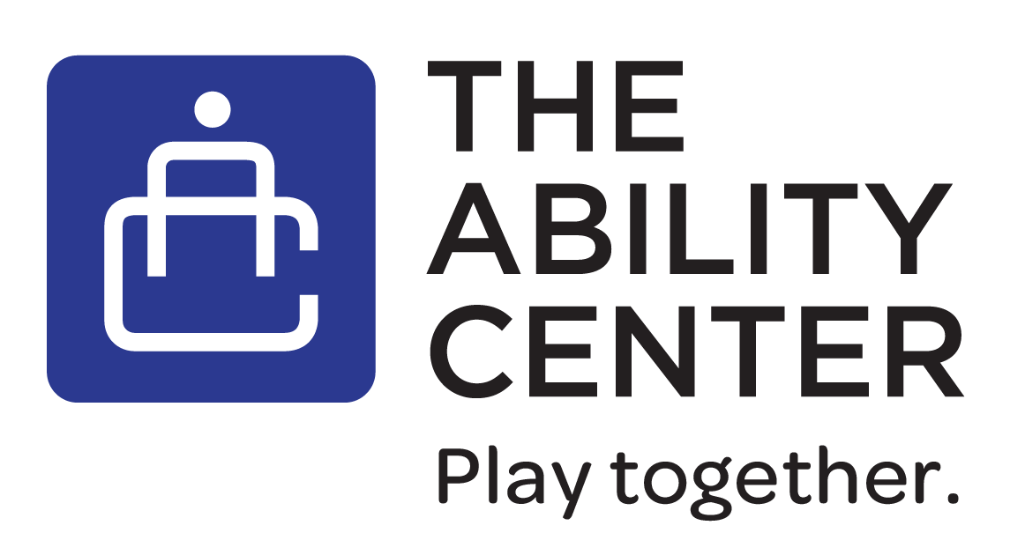

**THE ABILITY CENTER HOSTS 3rd ANNUAL UNSTOPPABLE CUP PRESENTED BY BAIRD**

**SOLD OUT AGAIN**

**\*\*\*Photo opportunities and interviews available\*\*\***

**When: Friday, March 14, 2025**

11:00 a.m. - 5:00 p.m. CT

* Tournament co-hosts Duane McAllister (Baird) and Derek Smith (AILCO) available for photos and interviews.
* Founder and Executive Director of The Ability Center Damian Buchman will also be available.

**Where: Harry & Rose Samson Family Jewish Community Center (JCC)**

Marcus Gym

6255 N. Santa Monica Blvd.

Whitefish Bay, Wisconsin

**What**:

The Unstoppable Cup, a 3v3 Charitable Wheelchair Basketball Tournament, invites corporate teams to come play in a “different pair of shoes” and experience adaptive sports while supporting the mission of The Ability Center. The generous support of sponsors and teams helps The Ability Center to provide individuals impacted by disabilities with the daily opportunity to be fit, active, be healthy and to play. With this support The Ability Center can continue to build communities where all abilities are provided with a universal opportunity for health, wellness and recreation, and can play together.

This year, more than 100 participants will take to the court. Fifteen organizations are returning, and three new organizations are joining the fun in 2025. The Ability Center welcomes back: Baird, Permobil, Artisan, Rockwell Automation, PNC Bank, Mueller Communication, Catalyst Construction, Crescent Grove Financial, SRH Marketing, Kahler Slater, Northshore Bank, Borgman Capital, Manpower, Johnson Financial and Wauwatosa Police Department. And, welcomes newly participating organizations Fiserv, Waterstone Bank and The Harry and Rose Samson Family Jewish Community Center!

This year’s event presenting sponsors are Baird and Fiserv! Additional sponsors include Permobil, Artisan Partners, Catalyst Construction, PNC Bank, SRH Marking, Hanger Clinic, Crescent Grove Financial, Goodman Family Insurance, Kahler Slater, Ailco and Festival Foods!

**CONTACT**: Nicole Angresano, The Ability Center

262-409-3800; [nicole@TACwi.org](mailto:nicole@TACwi.org)

**Additional Information**: [www.tacwi.org](http://www.tacwi.org)

**About The Ability Center**:

The Ability Center’s (TAC) goal is to provide a higher quality of life for people of *all* abilities by transforming greater Milwaukee into the most *universally inclusive* recreation destination in the world. TAC achieves its mission, to provide people *impacted* by disabilities with a *daily* opportunity to be fit, active, healthy, and to play, through four initiatives: RampUp: Universal Community, which designs, builds and/or implements universally *inclusive* recreational *opportunities*; Open Gym: Adaptive Programs, partners with community-based nonprofits, and parks & recreation departments – Open Gym provides an opportunity for people of all abilities to play *together* in an inclusive, non-competitive, friendly environment where your friends, family, peers and/or colleagues can join you to play in a “Different Pair of Shoes;” ASAP: Inclusive Education, a school-based *Adaptive Scholastic Athletic Program (ASAP)*, hosts disability awareness assemblies and *inclusive* physical education classes, and TAC: Social a peer group for teens and young adults with physical disabilities co-led by adult mentors with physical disabilities. Connect with us on [tacwi.org](https://tacwi.org/), [Facebook](https://www.facebook.com/TheAbilityCenter), [Instagram](https://www.instagram.com/tacwi/?hl=en) and [LinkedIn](https://www.linkedin.com/company/1476237/admin/).

###