SHINJUKU SONG INFORMATION
BAND BIO
About The Keystones
The Keystones are a Milwaukee, Wisconsin-based modern rock band featuring Jack Sherman (vocals, rhythm guitar), Matt Sherman (vocals, bass) Eddie Curran (drums) and Ryan “Wally” Walkoe (lead guitar). Born in Waukesha, the very same place as the electric guitar, the members of this stadium indie group hail from the golden era of 2000s grunge guitar, one that’s full of heavy tones and hypnotizing garage beats that dance between Brit-indie-grunge and new-age alternative sounds. The Keystones have opened for acts such as Fitz & the Tantrums, Badflower, Reignwolf, Dead Poet Society, Harbour, Dirty Honey and more.

SONG BACKGROUND: SHINJUKU
Quick Blurb About SHINJUKU: Never stopping, always moving, programmed to be self-improving. The fourth single in The Keystones’ sophomore hard-rock EP is SHINJUKU, a funky, synth-pop, hard rock track that defies genres while sending a very clear message: burnout culture is eating us alive. SHINJUKU was inspired by the notion of Japanese “Salarymen,” figures depicted in media as fiercely loyal to their jobs and employers—while suffering from the isolation and exhaustion of a society that prioritizes work above all else. SHINJUKU will serve as the premier release of a 5-track hard rock EP titled Do You Work Hard Enough?, and was produced by engineer Derek Moffat of 608 Studios.

SHINJUKU LYRICS
[Verse]
Pick yourself up off the floor and get it done
Quit your party talking finish it for once
Motivation, inspiration, muses
None of them come from the words
Spilling out of your lungs

[Pre-Chorus]
We thrive
As one
[Chorus]
You can’t just say
I want it
You gotta go
Do it
You can’t just say
I like it
You gotta go

[Verse]
Move your feet to the sound of the rising sun
Make a lot of promises don’t get them wrong
It won’t matter if your heart’s not in it long
Climb the ladder
Will you shatter
Under pressure
From your tongue?
[Chorus]
You can’t just say
I want it
You gotta go
Do it
You can’t just say
I like it
You gotta go

[Bridge]
Motivation, inspiration, total self-annihilation
Never stopping, always moving, programmed to be self-improving
[Chorus]
You can’t just say
I want it
You gotta go
Do it
You can’t just say
I like it
You gotta go
You can’t just say
I want it
You gotta go
Do it

PRESS RELEASE
FOR IMMEDIATE RELEASE
The Keystones Release New Alt-Heavy Track, SHINJUKU
After a year of shows alongside Badflower, Dead Poet Society and others, band looks to SXSW showcase and new song release

MILWAUKEE, WI — After a series of high-profile shows—including providing direct support for Badflower at the Sylvee in Madison, WI in September 2024—The Keystones announced the release of a new track, SHINJUKU, on 2/21. The song is the fourth track in the band’s forthcoming 5-song EP, Do You Work Hard Enough?, and will be supported by a SXSW showcase and Southern-Midwest tour in March.
SHINJUKU continues the hard rock direction the band has taken since they began releasing their sophomore EP single by single—while also adding funk-rock and synth-pop elements inspired by UK bands Kid Kapichi and DON BROCO. Like much of the EP, SHINJUKU is a critique on burnout culture, dissecting what it means to succeed as a professional in modern society.

Above: The Keystones performing at The Sylvee in Madison, WI. Photo by Kelley Curran.
“We’ve been talking a lot about American capitalism in this EP—how frustrated people are by working long hours for increasingly stagnant pay,” said Keystones singer Jack Sherman. “But there’s a whole world out there, and we’re not alone in our work-to-live mindset. SHINJUKU is our way of responding to deeply ingrained aspects of Japanese culture that mirror our own. Take ‘Salarymen,’ for example—white-collar workers who are often portrayed in film and other media as showing unwavering loyalty to their employers in lieu of making deeper community and familial connections.”

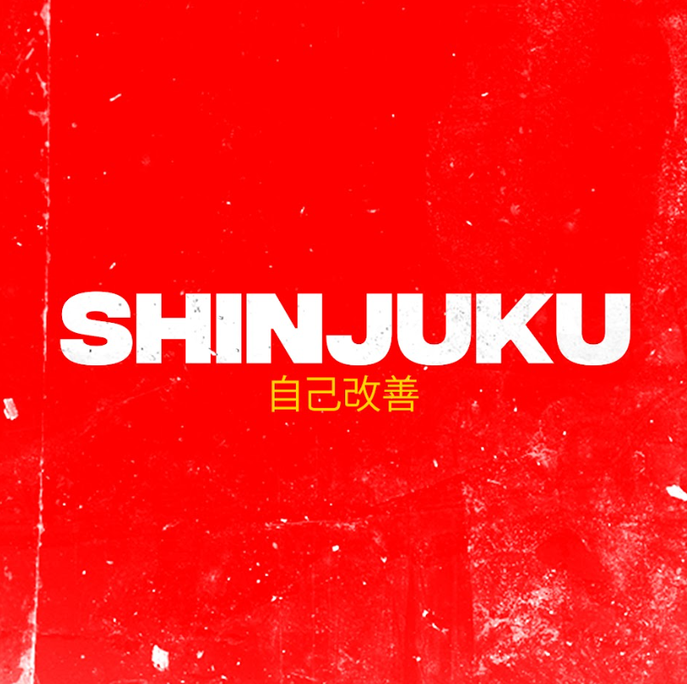
Above: Song art for the next release by The Keystones, “Red and Blue”.

SHINJUKU was produced by engineer Derek Moffat. The full, 5-song EP will be available in May 2025, and a deluxe version with additional tracks will follow in summer 2025.
Touring & Shows
In addition to high-profile performances at SXSW and LAUNCH Music Conference, The Keystones have served as direct support to indie pop icons Fitz & The Tantrums at Summerfest, Dead Poet Society, Badflower, Dirty Honey, Harbour, Reignwolf, Michigander and others. Regional runs include a tour alongside The Honest Hearts Collective.
Contact
If you’re interested in featuring The Keystones in your publication, please contact manager Nick Heath at Gold Firebird (nick@goldfirebird.com). The band can be found on Facebook and Instagram and other social media platforms.
PRESS
- Earmilk - Chameleons
- Alternative Press - AP&R Artists to Watch
- Hollywood Life Premiere - Time Will Tell
- 88.9 Radio Milwaukee Premiere of WLVS
- The Symphony of Rock - 'The Keystones Release WLVS'
- Burnt Coffee Reviews - 'A Quick Review of The Keystones' New Single WLVS'
- Artists Beating COVID-19: The Keystones - Shepherd Express
###
About The Keystones
The Keystones are a Milwaukee, Wisconsin-based modern rock band featuring Jack Sherman (vocals, guitar), Matt Sherman (vocals, bass), Eddie Curran (drums) and Ryan “Wally” Walkoe (lead guitar). Born in Waukesha, the very same place as the electric guitar, the members of this modern hard rock group hail from the golden era of 2000s grunge guitar, one that’s full of heavy tones and hypnotizing garage beats that dance between Brit-indie-grunge and punk. The Keystones have played alongside acts such as Reignwolf, Dead Poet Society, Harbour, Michigander, Dirty Honey, Badflower, Fitz & The Tantrums and more.

UPCOMING SHOWS
- 2/28 – show at Cactus Club, Milwaukee, WI
- 3/7 – show at Falcon Hall, Milwaukee, WI
- 3/8 – show at Platypus, St. Louis, WI
- 3/9 – show at Grand Royal, Oklahoma City, OK
- 3/10-3/12 – SXSW showcase
- 3/15 – show at Cubby Bear
- 3/22 – show at Vivarium, Milwaukee, WI

