

January 22st, 2025

City of Milwaukee - City Hall

200 E. Wells Street

Room 705

Milwaukee, WI 53202

Dear Milwaukee Fire & Police Commission Members,

We, the undersigned members of the Wisconsin State Legislature, respectfully ask that you reconsider your recent decision to not promote Milwaukee Police Department (MPD) Officer Jason Daering to the rank of Sergeant.

Officer Daering is well-respected amongst his fellow officers and has proven to be a high performing officer in the department. He is considered by many to be a “cop’s cop” who protects his community with the utmost professionalism and integrity. He passed the rigorous vetting process and received recommendations for promotion, not only from MPD Chief Jeffery Norman, but by the MPD Internal Affairs Division. Additionally, Officer Daering has been previously recognized for his distinguished service including the Medal of Valor for his actions in the line of duty. We should be rewarding and recognizing his commitment to proactive policing at a time when the City of Milwaukee desperately needs proactive officers. Officer Daering’s record and recommendations indicate he has earned this promotion.

In regards to the above points, we respectfully ask you to reevaluate and reconsider your decision. Failure to do so will have an adverse impact on the already low morale of MPD.

Respectfully,

Bob Donovan

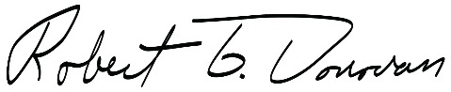

State Representative

61st Assembly District

Barb Dittrich

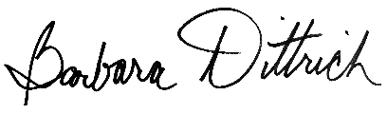

State Representative

99th Assembly District

Cindi Duchow

C:\Users\sgieschen\AppData\Local\Microsoft\Windows\INetCache\Content.Word\Signature.jpg

State Representative

97th Assembly District

Rick Gundrum

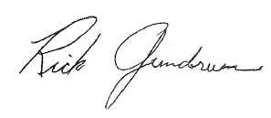

State Representative

58th Assembly District

Amanda Nedweski Jim Piwowarczyk

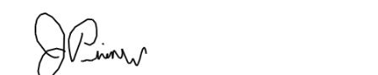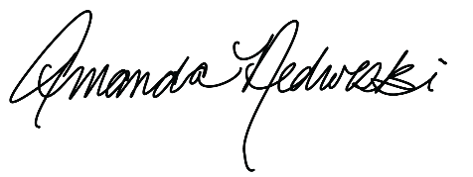

State Representative State Representative

32nd Assembly District 98th Assembly District

Dan Knodl Jerry O’Connor

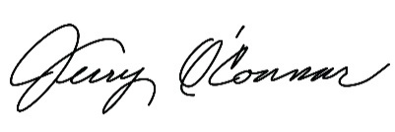C:\Users\sgieschen\AppData\Local\Microsoft\Windows\INetCache\Content.Word\Knodl Signature.jpg

State Representative State Representative

24th Assembly District 60th Assembly District

Dave Maxey Paul Melotik

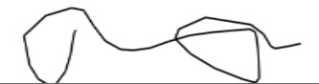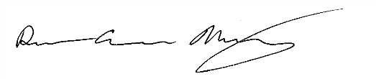

State Representative State Representative

83rd Assembly District 22nd Assembly District

Robert Wittke Jessie Rodriguez

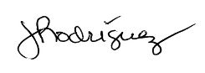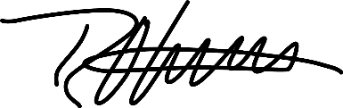

State Representative State Representative

63rd Assembly District 21st Assembly District

Todd Novak Van Wanggaard

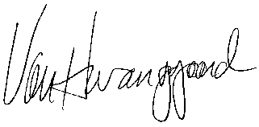

State Representative State Senator

51st Assembly District 21st State Senate District

Julian Bradley

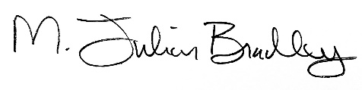

State Senator

28th State Senate District