FOR IMMEDIATE RELEASE

**MOWA’s Adolph Rosenblatt exhibition celebrates his masterwork, *My Balcony***

*Impressions in Clay* captures the essence of human interaction through expressive, textured ceramic works

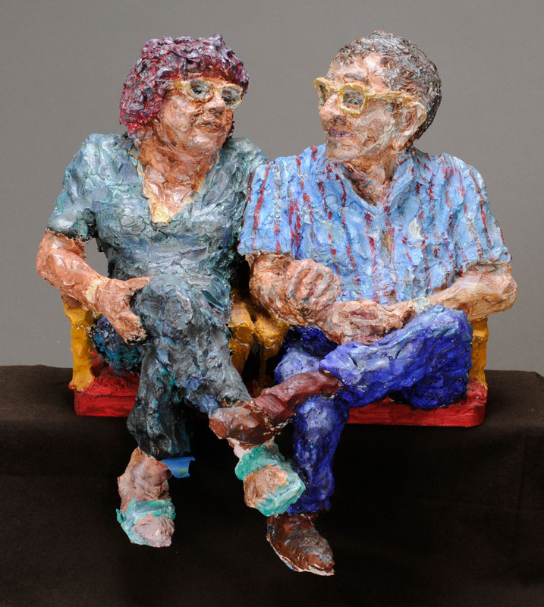(West Bend, WI) Museum of Wisconsin Art is delighted to announce *Impressions in Clay: The Sculpted World of Adolph Rosenblatt,* on view from January 29 to April 13. This exhibition showcases the distinctive sculptural style of Adolph Rosenblatt, renowned for his highly textured, impressionistic approach to clay. At the heart of the exhibition is Rosenblatt’s monumental piece, *My Balcony*, a mass portrait depicting 81 individuals seated at Milwaukee’s Oriental Theatre that he crafted over a two-year period from 1995–1997. All 10 works presented in *Impressions in Clay* are drawn from MOWA’s permanent collection.

Rosenblatt was captivated by individuality as well as the shared experiences of the human condition. In *My Balcony*, the artist succinctly captures the essence of connection and interaction between people: friends, family, and colleagues sharing a moment of anticipation as they wait for a movie to begin.

“After a decade of painting, Rosenblatt found his true calling in clay—a medium that allowed him to sculpt the world around him with his hands." said Thomas Szolwinski, Associate Curator of Architecture and Design at MOWA. He added, "His impressionistic sculpting style remains as distinctive today as when he first started."

Rather than using traditional tools, Rosenblatt used his hands to sculpt, resulting in highly textural, expressive surfaces that vividly capture posture and gesture. His ceramic sculptures, with their rich, tactile quality, offer a unique perspective on human form and interaction. “In 2018, we received a major gift of Rosenblatt’s ceramic works from the Kohler Foundation,” said Jane Aspinwall, MOWA’s Deputy Director. “Considering his significant impact on the Milwaukee art community, we are excited to have this work on view for the first time here at MOWA.”

Rosenblatt received a bachelor of fine arts at the Yale School of Art and Architecture where he was mentored by Josef Albers. In 1966, Rosenblatt moved to Milwaukee to join the University of Wisconsin-Milwaukee as an art professor, where he served until his retirement in 1999.

Join MOWA for *Impressions in Clay: The Sculpted World of Adolph Rosenblatt* and discover the artist’s energetic, expressive portrayal of the human experience.

**IMAGE CREDIT**

Adolph Rosenblatt, *My Balcony*, 1997 (detail)

**ABOUT THE MUSEUM OF WISCONSIN ART**

A vital cultural center, educational institution, an expanding network of ideas, the Museum of Wisconsin Art (MOWA) collects and interprets American art through the lens of a single state. Informed by dynamic initiatives and collaborations, MOWA is an innovative forum for contemporary artists, socially relevant exhibitions, lectures by artists and industry experts, and engaging classes and activities for all ages.

MOWA has two permanent venues—the West Bend “Mothership” and MOWA | DTN in downtown Milwaukee’s Saint Kate—The Arts Hotel—as well as two partnering community organizations that create access across the state. MOWA annually welcomes 200,000 visitors, making it a cultural destination for the art and artists of our time.

[wisconsinart.org](http://www.wisconsinart.org/)

[facebook.com/museumofwiart](http://www.facebook.com/museumofwiart)

[instragram.com/museumofwiart](http://www.instragram.com/museumofwiart)

[twitter.com/museumofwisconsinart](http://www.twitter.com/museumofwisconsinart)

[youtube.com/user/MuseumofWisconsinArt](http://www.youtube.com/user/MuseumofWisconsinArt)

MEDIA CONTACT

Isabel Sandretti

Marketing + Communications Specialist

262-247-2266 | [isandretti@wisconsinart.org](mailto:isandretti@wisconsinart.org)