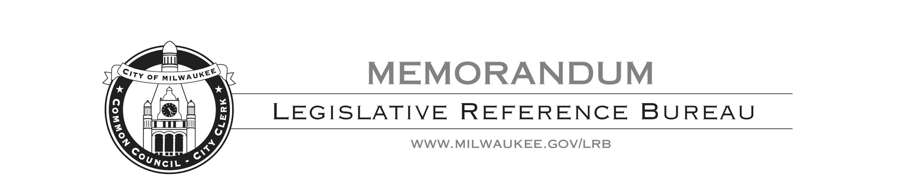

To: Ald. Marina Dimitrijevic
From: Luke Knapp, Legislative Fiscal Analyst
Date: July 6, 2020
Subject: Masking Policies – New York, Los Angeles and Phoenix

Recently, you asked the Legislative Reference Bureau for a comparison of the policies in New York, Los Angeles and Phoenix which require individuals to wear masks in public spaces. Below is a description of each policy, and the key areas in which they differ from the other.

New York
New York’s masking policy is a blanket statewide policy requiring every person above the age of 2, notwithstanding a medical condition which would prohibit the wearing of a mask, to wear a mask whenever in a public space. Where some cities have various exceptions, such as during outdoor exercise or when no other individual is present, New York’s policy is incredibly wide in its scope. However, the state order does not impose specific citations or fines for noncompliance, and shifts enforcement to local law enforcement agencies. It is generally understood that law enforcement will not fine or arrest an individual for not wearing a mask, but, rather, give a verbal warning. In interviews, Governor Cuomo has suggested municipalities create a small fine for persistent noncompliance; however, New York City has not yet taken legislative action to create a fine, and Mayor Bill de Blasio has publically state that he prefers education over enforcement.

Los Angeles
Los Angeles is similar to New York in having a large blanket policy with no specific citations or fines described in the order. While New York’s policy appears to be intentionally vague in its description of when to wear a mask, Los Angeles describes the order to be in effect in the following circumstances:
- If you visit any retail business, including those that are open only for curbside or doorside pickup.
- If you exercise in your neighborhood or are on a trail, golf course or beach.
- If you ride on L.A. Department of Transportation transit buses, Metro buses or trains, or travel through Los Angeles International Airport

Similar to New York, children under 2 and people with certain disabilities are exempt from the mask requirement. Also similar to New York, there are no specific fines or citations. Enforcement is done by verbal warnings and education by law enforcement.

Phoenix
Phoenix has the most detailed order of the three jurisdictions, with specific details of when to wear a mask and lengthy list of exceptions. Phoenix requires all persons six years old or older have a mask with them when they leave their home or place of residence and wear the mask whenever they are within six feet of another person who is not a member of their family or household. There are a few exceptions to this requirement:
- Those who fall into the CDC guidance for individuals who should not wear face coverings due to a medical condition, mental health condition, development disability, or are otherwise covered under the Americans with Disabilities Act.
- Children under 6 years old.
- People whose religious beliefs prevent them from wearing a face covering,
- Restaurant patrons while they are dining.
- Individuals exercising outdoors or while walking or exercising with other people form the same household, if social distancing from others who are not your family members can be maintained.
- Those engaging in organized group or team sports, exercise or other physical activities where it is not practicable or feasible to wear a mask or socially distance.
- In a setting where it is not practical or feasible to wear a face covering, including when obtaining or rendering goods or services, such as the receipt of dental services or medical treatment.

Phoenix, unlike New York and Los Angeles, also dictates that a person or business may also face a civil citation fine between $0 and $250, at the court’s discretion. Businesses are also given the right to refuse service to an individual for failure to comply, and details that enforcement of this measure should be administered first by education and an opportunity for compliance, followed by a warning, and only after then a civil citation if necessary.

The largest distinction between the three cities is the mechanisms of enforcement. Los Angeles and New York orders do not have citations tied to them, meaning the rules can be vaguer and more encompassing. By tying a specific citation for noncompliance, Phoenix has more specific details regarding exceptions to enforcement.

The City of Milwaukee’s proposed ordinance would combine the two approaches by establishing different mask requirements for indoor and outdoor settings. The outdoor requirements would follow those of San Francisco and require individuals to have a mask on their person and wear the mask when they see another individual within 30 feet of them. The indoor requirements are more stringent, and require masks be worn any time an individual is in an indoor public space. The indoor requirements charge business operators with ensuring compliance by those inside the business, or they may be subject to a warning, citation or being shut down by the Health Department. If a business has a patron that refuses to comply with the regulation, the Health Department may give a warning and a citation to the individual, rather than the business.

LRB 176208-2

