PROCLAMATION BY THE MAYOR
Whereas, on March 15, 2020, I declared an emergency in the City of Milwaukee under Wisconsin Statutes s. 323.14(4)(b) and Milwaukee City Charter s. 6-07-3 due to the public health emergency associated with the COVID-19 pandemic;
Whereas, the Common Council of the City of Milwaukee has since ratified that declaration per file number 191881, 191907, and 200052 on March 18th, March 24th, and May 8th of 2020, respectively;
Whereas, under the City’s stay-at-home order, essential government functions include services provided by certain general city employees that are needed to ensure the continuing operation of the government body and provide and support the health, safety, and welfare of the public;
Whereas, those essential functions also include employees working in essential, front-line, direct service roles in preparing, preventing, or responding to the COVID-19 public health emergency;
Whereas, some employees performing critical infrastructure work and others involved in the City’s response to the COVID-19 pandemic face a higher risk of exposure;
Whereas, given the elevated risk noted in the performance of some of the aforementioned responsibilities, the City must do what is necessary to maintain and retain appropriate staffing levels to provide continued essential services as well as ensure that essential direct roles responding to the pandemic are fully staffed; and
Whereas, confirmed cases of COVID-19 in the City of Milwaukee continue to occur daily;
Whereas, Milwaukee Health Department Order #2, revised May 21, 2020, defines physical distancing as maintaining six feet between people not residing in a single living unit or household;
Whereas, Milwaukee Health Department Order #2 requires all bars, restaurants, and places of public amusement and activity to meet physical distancing requirements;
Whereas, activities held outdoors pose lower risk for transmission of COVID-19 than those done in indoor spaces;
Now Therefore, I Tom Barrett, Mayor of the City of Milwaukee, under the power vested to me by Wisconsin Statutes s. 323.14(4)(b) and Milwaukee City Charter 6-07-3, declare that the state of emergency continues in the City of Milwaukee and it is necessary and expedient for the health, safety and protection of the city to authorize the creation of hazard pay in the amount of $3.13 per each hour actually worked for certain employees or positions with responsibilities that entail a higher risk of exposure, including those that:
- carry regular public facing duties;
- require the employee to regularly enter occupied residences or commercial establishments;
- require repeated and prolonged contact with COVID-19 symptomatic individuals;
- include cleaning and building maintenance work performed on the grounds of a City property;
- perform specimen collection, medical testing and diagnostic services;
- involve behavioral health work requiring physical interaction with individuals including mental health services, violence prevention, substance use and prevention;
- require repeated or prolonged contact with potentially contaminated spaces, objects or property; and,
- perform maintenance or mechanical work on City vehicles or equipment used by employees performing critical infrastructure work who face risk of exposure.

I also authorize the Department of Employee Relations to establish and enforce the administrative and operational guidelines to implement hazard pay provisions. Hazard pay as defined by such guidelines will commence immediately and will expire on July 27, 2020.
I further declare that the following City of Milwaukee ordinances governing fees related to parklets are suspended and fees waived for the duration of this Proclamation, under the terms and conditions set forth in this Proclamation, and only to the extent necessary to effectuate this Proclamation:
- Parklets – Sec. 81-102-4.5
- Parking Meter of Parking Space Marker Temporary Removal of Hooding – Sec. 81-83-4
All other fees in Milwaukee Code of Ordinances Secs. 81-102 and 81-83 remain in effect unless suspended or waived by an existing Proclamation.
Signed and sealed with the official seal of the City of Milwaukee this 22nd day of May, Two Thousand and Twenty in Milwaukee, Wisconsin.
By:
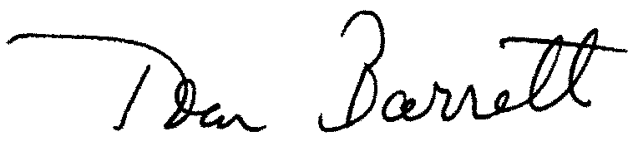
Tom Barrett
Mayor

