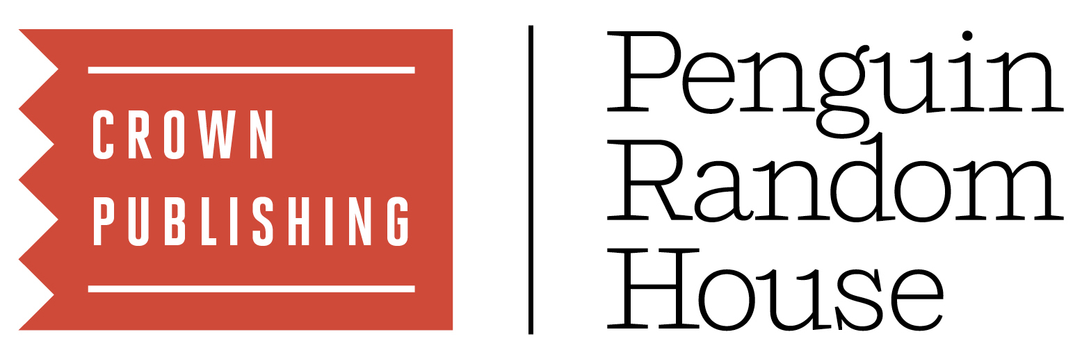
LIVE NATION AND CROWN PUBLISHING ANNOUNCE 2019 DATES FOR FINAL LEG OF MICHELLE OBAMA’s BOOK TOUR

Click here for a video compilation from Mrs. Obama’s tour thus far

Tickets for North American dates will go on sale to the general public starting Saturday,
December 15, at 10 a.m. local time, and starting Friday, December 14, for European dates

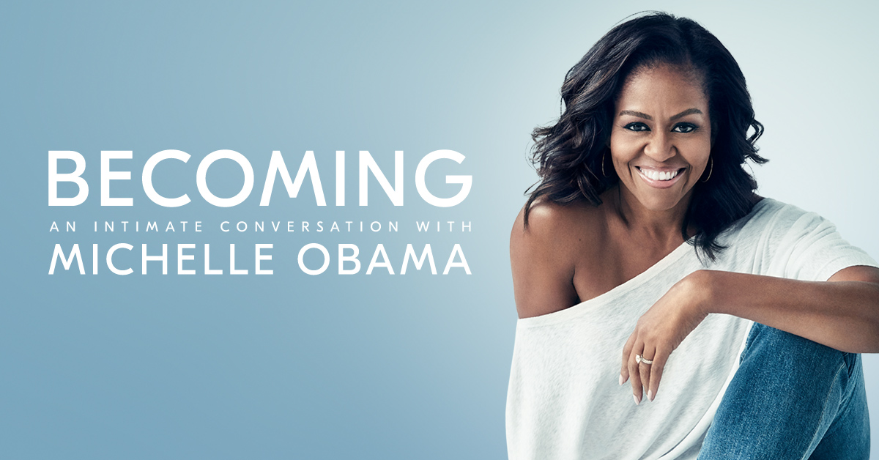

Dec 11, 2018 – After a highly successful 2018 12-event arena tour across 10 cities, Live Nation and Crown Publishing, a part of Penguin Random House, are pleased to announce that additional dates and cities have been added to Becoming: An Intimate Conversation with Michelle Obama.
This extension of the tour will include 21 events in 2019 across North America and Europe produced by Live Nation, including 11 additional events in the U.S., 4 in Canada, and 6 in Europe. The 2019 events will kick off on February 8 in Tacoma, WA, and will make stops in previously unvisited cities, including Austin, Toronto, Atlanta, Copenhagen, Amsterdam, and more. The European dates will include an event in Paris, rescheduled from the original December 5, 2018, date which was delayed due to Mrs. Obama’s trip back to the U.S. to attend the late President George H.W. Bush’s funeral. The 2019 events will also see Mrs. Obama visiting a range of venues, from arenas to more intimate theaters. Each stop will feature to-be-announced moderators who will appear in conversation with the former First Lady. The final event will take place on May 12 in Nashville, TN, concluding the Becoming book tour.

Mrs. Obama is dedicated to ensuring tickets are put into the hands of real fans, and not resold on secondary websites. That is why Live Nation and European ticket agencies are implementing various methods to limit ticket scalpers on the Becoming book tour. The North American events will utilize Ticketmaster’s Verified Fan® platform. Fans can register now through Wednesday, December 12, at 10 p.m. PST HERE for the Verified Fan presale. Registered fans who receive a code will have access to purchase tickets for the North American events before the general public on Friday, December 14, from 10 a.m. local time to 10 p.m. Information on the ticketing methods for the European events is available at each city’s respective ticketing website.

Tickets for the newly announced North American 2019 dates will go on sale to the general public beginning Saturday, December 15, at 10 a.m. local time at BecomingMichelleObama.com. A limited number of VIP meet and greet packages with the former First Lady will also be available.

Local general on-sale timing for European events are listed below.

In keeping with her commitment to make her events accessible to as many people as possible, Mrs. Obama and Live Nation will donate a portion of ticket inventory in each market to various organizations, including, but not limited to, charities, schools, and community groups in each city the tour visits. Those fans will receive free admission to the tour stop in their city.

Attendees at Mrs. Obama’s events will hear her honest reflections on the experiences and events, both public and private, that have shaped her, from her childhood on the South Side of Chicago to her years as an executive balancing the demands of motherhood and work, to her years spent at the most famous address in the world. Michelle Obama has emerged as one of the most iconic and compelling women of our era. As First Lady of the United States – the first African-American to serve in that role – she helped create the most welcoming and inclusive White House in history, while also establishing herself as a powerful advocate for women and girls in the U.S. and around the world.

"I couldn't be more excited to visit even more cities across the country and around the world," Mrs. Obama said. "I've been so humbled by the response to the tour thus far and the overwhelming interest we’ve received from so many communities we weren’t able to visit this year. That’s why I’m thrilled that we’re able to expand our conversations to these new settings and wider audiences. I can’t wait to continue the discussions that have been so meaningful for me and, I hope, for so many others.”

BECOMING was released on November 13 in the U.S. and Canada by Crown Publishing, a part of Penguin Random House, as well as in 33 languages around the world. Since its publication, BECOMING became an instant #1 New York Times bestseller after one week of sales, and has sold more than 3 million units in all formats and editions in the U.S. and Canada. According to NDP BookScan data, the hardcover edition of BECOMING has sold more copies than any other book published in the United States in 2018. After six printings, the hardcover edition of BECOMING will have 3.8 million copies in print in the U.S. and Canada and a total of 6 million copies in print worldwide. The book is also a #1 bestseller in 11 other countries around the world. An audio edition of the book, read by Mrs. Obama, is also available in digital and physical formats by Penguin Random House Audio.

BECOMING: AN INTIMATE CONVERSATION WITH MICHELLE OBAMA 2019 DATES:
Friday, February 8, 2019 | Tacoma, WA | Tacoma Dome
Saturday, February 9, 2019 | Portland, OR | Moda Center
Tuesday, February 12, 2019 | Phoenix, AZ | Comerica Theatre
Thursday, February 28, 2019 | Austin, TX | Frank Erwin Center
Saturday, March 2, 2019 | Houston, TX | Toyota Center
Wednesday, March 13, 2019 | St. Paul, MN | Xcel Energy Center
Thursday, March 14, 2019 | Milwaukee, WI | Miller High Life Theatre
Saturday, March 16, 2019 | Cleveland, OH | KeyBank State Theatre
Thursday, March 21, 2019 | Vancouver, BC | Pepsi Live at Rogers Arena
Friday, March 22, 2019 | Edmonton, AB | Rogers Place
Tuesday, April 9, 2019 | Copenhagen, Denmark | Royal Arena
Wednesday, April 10, 2019 | Stockholm, Sweden | Ericsson Globe
Thursday, April 11, 2019 | Oslo, Norway | Oslo Spektrum
Sunday, April 14, 2019 | London, UK | The O2 Arena
Tuesday, April 16, 2019* | Paris, France* | AccorHotels Arena*
Wednesday, April 17, 2019 | Amsterdam, Netherlands | Ziggo Dome
Friday, May 3, 2019 | Montreal, QC | Bell Centre
Saturday, May 4, 2019 | Toronto, ON | Scotiabank Arena
Friday, May 10, 2019 | Ft. Lauderdale, FL | BB&T Center
Saturday, May 11, 2019 | Atlanta, GA | State Farm Arena
Sunday, May 12, 2019+ | Nashville, TN+ | Ryman Auditorium+

*Rescheduled from original December 5, 2018 date
+all tickets will be sold through Verified Fan, beginning Fri. Dec 14 at 10am local time. Please see registration details above.

EUROPEAN REGISTRATION AND ON-SALE TIMING:

Denmark, Copenhagen (Royal Arena, April 9, 2019):
General on-sale begins: Friday, December 14, 10:00 a.m. local

Stockholm, Sweden (Ericsson Globe, April 10, 2019):
General on-sale begins: Friday, December 14, 9:00 a.m. local

Oslo, Norway (Oslo Spektrum, April 11, 2019):
General on-sale begins: Friday, December 14, 9:00 a.m. local

London, United Kingdom (The O2 Arena, April 14, 2019):
General on-sale begins: Friday, December 14, 1:00 p.m. local

Paris, France (AccorHotels Arena, April 16, 2019):
General on-sale begins: Friday, December 14, 12:00 noon local

Amsterdam, Netherlands (Ziggo Dome, April 17, 2019):
General on-sale begins: Friday, December 14, 11:00 a.m. local

About Live Nation Entertainment
Live Nation Entertainment (NYSE: LYV) is the world’s leading live entertainment company comprised of global market leaders: Ticketmaster, Live Nation Concerts, and Live Nation Sponsorship. For additional information, visit www.livenationentertainment.com.

About Crown Publishing
Crown Publishing is a part of Penguin Random House, the world’s largest trade book publisher, which is dedicated to its mission of nourishing a universal passion for reading by connecting authors and their writing with readers everywhere. The company, which employs 10,000 people globally, was formed on July 1, 2013, by Bertelsmann and Pearson, who own 75 percent and 25 percent respectively. With more than 250 independent imprints and brands on five continents, Penguin Random House comprises adult and children’s fiction and nonfiction print and digital English- and Spanish-language trade book publishing businesses in more than 20 countries worldwide. With 15,000 new titles, and 600 million print, audio, and ebooks sold annually, Penguin Random House’s publishing lists include more than 60 Nobel Prize laureates and hundreds of the world’s most widely read authors.

Information about press access is still being determined.
For further updates, please fill out the form below:
https://goo.gl/forms/SwRq2rkoEdSWT4DA3

Becoming by Michelle Obama Media Contacts:

Crown Publishing/Penguin Random House
Carisa Hays, chays@penguinrandomhouse.com

Live Nation
Emily Bender, emilybender@livenation.com
Monique Sowinski, moniquesowinski@livenation.com

