STATE OF WISCONSIN CIRCUIT COURT MILWAUKEE COUNTY

GHALEB IBRAHIM, Case No. 11CV015178
JATINDER CHEEMA, and
AMITPAL SINGH, Declaratory Judgment: 30701
Other Injunction: 30704
Plaintiffs,

v.

CITY OF MILWAUKEE,
a municipal corporation,

Defendant.

DECLARATION AND AFFIDAVIT OF PLAINTIFFS’ EXPERT WITNESS SAMUEL R. STALEY, Ph.D.

Samuel R. Staley, being duly sworn, deposes and says:
1. My name is Samuel R. Staley. I received a B.A. degree from Colby College in 1984 with majors in economics and public policy, an M.S. degree from Wright State University in 1987 in social and applied economics, and a Ph.D. from The Ohio State University in public administration in 1997.
2. I currently teach an advanced undergraduate course in research methods at Florida State University as a faculty member of the DeVoe L. Moore Center, an interdisciplinary unit in the College of Social Sciences and Public Policy. I also have served, since 2006, as an adjunct instructor at the Department of Economics and Finance at the University of Dayton, and from 1990 to 1995 served as a full time instructor in the Department of Economics at Wright State University. I am also a senior research fellow at the Reason Foundation, where I have held various research positions from 1997 to 2002 and from 2005 through the present, and a senior research fellow at the Buckeye Institute for Public Policy Solutions, where I have held various research and leadership positions since 1994. A copy of my full resume is attached as Exhibit A to this Affidavit.
3. I have extensive experience in transportation economics and policy, including that related to taxicabs. I have served as principal investigator or author on several studies directly evaluating taxicab regulation and economic opportunity, including Taxicab Regulation in Ohio’s Largest Cities (The Buckeye Institute, 1996), Giving a Leg Up to Bootstrap Entrepreneurship: Expanding Economic Opportunity in America’s Urban Centers (Reason Foundation, Policy Study 277, 2001), Recommendations for Taxicab Regulatory Reform for Port Chester, New York (IZS Consult, 2009), and Potential Impacts of an Taxi Fleet Expansion in Port Chester, New York (IZS Consult, 2011).
4. I was retained in this lawsuit to investigate the economic and entrepreneurial consequences of eliminating a cap on licensed taxi vehicles in the city of Milwaukee. This Affidavit sets forth my analysis and opinion on that subject. I received compensation of $7,500 inclusive of travel costs for a site visit for this research and analysis.
- Overview
5. My analysis draws on data provided by the city of Milwaukee, interviews with taxi drivers licensed by the City of Milwaukee, publicly available data from the U.S. Bureau of Labor Statistics, and original research produced for this project. In addition, the analysis relies on my twenty-five years of applied research on urban economic development and job creation and cumulative experience of more than fifteen years on the taxi industry and market. My research and analysis has included assessments of taxi regulations and their effect on economic opportunity in more than a dozen cities, including Cleveland, Cincinnati, Indianapolis, Dallas, Los Angeles, Boston, Washington, D.C., and Port Chester (NY). This background led me to be contacted by the plaintiffs’ attorneys to examine two issues as they relate to the potential effects of lifting the current cap on taxi vehicle licenses in the city:
- Whether the current cap limits current entrepreneurial opportunities for Milwaukee residents and current taxi drivers in particular;
- Whether entrepreneurial opportunities for current drivers and transportation services for the traveling public would be improved if the cap were lifted.
6. The following sections of this Affidavit examine these questions as they relate to general taxi service in the City of Milwaukee. This analysis does not necessarily extend to service provided by the Mitchell International Airport since the licensing and service levels are regulated by the airport authority and outside the scope of the current research project. The research was conducted using standard social science research methods, including quantitative database analysis, on-site observation, interviews with principal actors, case analysis, cross verification and validation of data, insights from the academic research, and my professional experience. The research was conducted primarily between March and August 2012 and included a multi-day site visit, one-on-one interviews, and small group interviews collecting specific observations and personal data from more than a dozen Milwaukee taxi drivers and vehicle owners. No attempt was made to filter the interviews by association with existing cab companies or status as an independent taxi driver.
7. The next section of this Affidavit examines the current state of the taxi market in the City of Milwaukee, providing an overview of the number of cabs, drivers, and companies and comparing its market structure to other similarly sized cities. The third section provides an overview of the economics of the taxi industry, examining the effects of different regulatory approaches on innovation, entrepreneurship, and service levels. Section Four examines the specifics of the Milwaukee taxi market from the perspective of an individual driver and discusses its implications for entrepreneurship. Section Five examines the potential economic implications of lifting the taxi vehicle cap, and Section Six concludes the Affidavit with observations for public policy.
- Current State of Milwaukee Taxi Market
8. As of March 2012, the city of Milwaukee had licensed 319 taxi vehicles and 1,303 drivers. The city has imposed an effective cap since January 1992 when it prohibited the issuance of new licenses. The vehicle licenses were distributed among 75 different owners at the time. The largest current licensee, Joe Sanfelippo Cabs, Inc., owns 35.7 percent, and the top three license holders control 59.6 percent of all outstanding vehicle licenses. Thus, despite a large number of drivers, ownership of vehicles is controlled by a very small number of license holders.

9. This is Table 1, detailing the largest Milwaukee taxi vehicle license holders:
Table 1: Largest Milwaukee Taxi Vehicle License Holders
Business | No. of Licenses
Joe Sanfelippo Cabs, Inc | 114
Yellow Cab | 54
GCC | 22
Roy WMS | 11
Frenchy Cab | 10
Tsounis Corp | 9
Harjinder, Virk | 6

10. To develop a better sense of how Milwaukee compares to similar sized cities, I identified four additional cities based on city population, metropolitan-area population, geography, regional economic status, and availability of data on taxicabs and drivers. Milwaukee is an economically independent, mid-size metropolitan area and city, despite its relatively close proximity to Chicago. The “peer” cities identified for this comparison were: Cincinnati, Columbus (OH), Indianapolis and Minneapolis. While the cities vary substantially in terms of city population, their respective metropolitan areas (the best unit of comparison for overall economic activity) are about the same size. Each of these peer cities operates as the dominant central urban area in their respective metropolitan areas except for Minneapolis. Minneapolis is a smaller city than Milwaukee, but operates within the larger Minneapolis-St. Paul metropolitan area and is included because of its geographic proximity as well as recent experience with taxicab deregulation (which will be discussed in later sections). Cincinnati, Columbus, and Indianapolis are about the same size as Milwaukee. Of the peer cities, however, only Columbus has a current limit on the number of taxi vehicle licenses issued. Notably, all peer cities have a significantly larger number of licensed taxicabs compared to Milwaukee. Minneapolis and Indianapolis have more than one thousand licensed drivers but more than twice the number of licensed taxi vehicles compared to Milwaukee.
11. This is Table 2, detailing the number of taxi vehicles and drivers that I identified as peer cities to Milwaukee:
Table 2: Taxi Vehicles and Drivers in Peer Cities
City | City Population (2010) | Metro Population (2010) | Licensed Taxi Drivers | Licensed Taxi Vehicles | Comments
Milwaukee | 594,833 | 1,555,908 | 1,303 | 319 | Cap on vehicles licensed
Cincinnati | 296,943 | 2,130,151 | 500 | 438 | No cap
Columbus (OH) | 787,033 | 1,836,536 | 897 | 500 | Moratorium on new licenses
Indianapolis | 829,450 | 1,756,241 | 1,174 | 820 | No cap
Minneapolis | 382,578 | 3,279,833 | 1,300 | 821 | No cap as of Jan 2011
Source: Population data are from U.S. Bureau of the Census (April 1 estimates). Taxi data were collected from individual cities by the author.

2.1 Market Concentration in the Milwaukee Taxi Market
12. Milwaukee’s taxi market appears to be highly concentrated compared to the peer cites (Figure 1). The largest single license holder in Milwaukee, Joe Sanfelippo Cabs, Inc., directly controls 35.7 percent of the total vehicles licensed. In Columbus, Ohio, another city with an effective cap on taxi vehicle licenses, Yellow/Green cab owns 25.6 percent of the licenses, and the top three directly control 34 percent of all vehicle licenses. In contrast, the single largest owners of licenses in the non-capped cities of Cincinnati and Indianapolis have significantly less dominance by the largest vehicle license holder: 18.7 percent and 21.8 percent, respectively.
13. This is Figure 1, detailing the ownership of vehicle licenses by the three largest taxi companies in Milwaukee, Cincinnati, Columbus, and Indianapolis:

14. The pattern of concentration becomes more apparent when the distribution of fleet size by vehicle license owner is compared. Taxi companies vary significantly in size, depending in part on the regulatory environment. For example, Columbus (and Cleveland) requires companies to have a minimum size of 25 cabs before they are classified as a company. While individuals can still own permits, they are not considered companies (and in Cleveland are required to become part of an Association). Highly regulated taxi markets are likely to have large concentrations of individual permit holders and a small number of firms with large numbers of permits. To more fully capture the concentration of permit ownership in cities, the pattern of permit ownership and concentration among individual owners was examined for Milwaukee, Cincinnati, Columbus, and Indianapolis.
15. In Milwaukee, 70.7 percent of individuals who own licenses have just one vehicle (Figure 2). Ninety percent of vehicle license holders own fewer than five permits. Meanwhile, just two license owners control 50 permits or more. (As noted in Table 1, one business is listed as a license holder for 114 vehicles.)
16. This is Figure 2, detailing the distribution of taxi vehicle license ownership in Milwaukee:

17. In contrast, Indianapolis is less concentrated and has a larger array of permit owners along the size categories (Figure 3). Fourteen percent of firms control licenses or permits for a fleet of 50 taxis or more, and 35.4 percent of the companies own more than 25 permits. Thus, more large firms compete in Indianapolis than in Milwaukee even though 57.5 percent of the licenses are owned by individuals with five or fewer vehicle permits. Similarly, Cincinnati appears to be less concentrated than Milwaukee although the distribution of permits shifts to mid-size companies (Figure 4). More than a quarter of vehicle licenses are held by owners or cab companies with between 6 and 15 permits, and another 4.7 percent are held by owners with 16 to 25 permits. No individual in Cincinnati owns more than 100 permits. Just 40 percent are single-taxi license holders (compared to 30.3 percent for Indianapolis).
18. Columbus, in contrast, has the largest share of single-vehicle license holders at 93.8 percent of all licenses with 97.6 percent of all licenses held by companies with fewer than two permits. Thus, Columbus appears to have very little opportunity for growing businesses beyond micro-enterprises (firms with one or two employees). In fact, one very large company, Yellow/Green cab, dominates the Columbus taxi market owning 128 permits. The second largest company, Acme Taxi, follows a distant second with 35 permits. The third large license holder in Columbus owns just seven permits.

19. This is Figure 3, detailing the distribution of taxi vehicle license ownership in Indianapolis:

20. This is Figure 4, detailing the distribution of taxi vehicle license ownership in Cincinnati:

2.2 Implications for Market Dynamics
21. In sum, Milwaukee’s taxi market appears to be unusually concentrated with fewer opportunities for growth beyond micro-enterprise status—firms with one or two employees—compared to similarly sized cities without caps. The cap likely limits economic and entrepreneurial opportunities by reinforcing trends toward increased consolidation and industry concentration for at least three reasons.
22. First, existing larger companies have an inherent advantage in the market over very small companies. Their size already allows them to tap into economies of scale and scope by distributing costs such as fuel, maintenance, and financing new vehicles over a larger fleet. A one-vehicle firm, for example, would not be able to hire a mechanic or demand specialized attention for its specific needs and requirements. A multivehicle company, on the other hand, can either internalize these costs by hiring a mechanic, maintaining a garage, or bidding in the market for specialized attention and services. Indeed, in interviews, taxi drivers complained of having to buy gasoline from a designated gas station as a requirement of their contract with a local cab company. Larger companies can, in principle, operate more efficiently. Combined with regulations that limit the entry of other companies to compete, existing large companies can exploit their market power, particularly in their lease agreements with drivers, to generate excess profits at the expense of current drivers and smaller competitors (e.g., increase lease rates for affiliated drivers in a limited market).
23. Second, larger firms, particularly in markets with substantial secondary markets for medallions and vehicle licenses, have a significant advantage over smaller firms and start-up cab companies in terms of their ability to finance expansions. Private finance companies, for example, underwrite the cost of buying taxi medallions in New York City because their value is stable over time (as a result of a policy-, not market-, induced scarcity). In New York, medallions have sold in private sales for over $1 million. In Milwaukee, private parties have bid as much as $200,000 for a permit. (This will be discussed further below.) If taxi permits were valued at $100,000 for illustrative purposes, this becomes an asset on which the company could borrow in the same way homeowners obtain home-equity loans or second mortgages on the remaining equity in their house. Thus, a company with two permits would have an asset valued at $200,000. If half of the value of these permits is equity (unencumbered by loans), the company could finance the purchase of a third license using the remaining equity in the first two permits. Clearly, in this economic environment, existing vehicle permit owners have significant advantages over their competitors, and the individuals (or businesses) with more permits have larger advantages. Meanwhile, those without a permit have a significant financial barrier (created through public policy); this effect will be discussed in the next section of this Affidavit.
24. Third, micro-enterprises find growth difficult, if not impossible to achieve in the constrained economic environment typical of the taxi industry. The data on the distribution of vehicle license ownership is particularly telling in this respect. While individual vehicle licenses are common, relatively few individuals own multiple permits, particularly in Milwaukee and Columbus (both of which prohibit expansion beyond the current number of licenses). Thus, larger companies are protected from competition by limiting the ability of individuals to incrementally grow their company to a competitive level.
25. In the Milwaukee context, single-vehicle owners rely principally on the revenue from their taxi activity which is, for most, insufficient to fund the purchase of a taxi license selling in the tens of thousands of dollars. (This will be discussed further in Section Four.) Many of the current license owners purchased their vehicle licenses before the steep rise in prices for permits in the 2000s. More problematically, expansion is economically infeasible for taxi drivers when the cost of financing one license is equivalent to financing a mortgage on a house. Unlike New York City, a commercially viable financing mechanism (e.g., a bank or lending agency) does not exist to fund the purchase of new licenses in Milwaukee, requiring taxi drivers to fund the purchase of licenses through personal savings or loans from family and friends.
26. The second and third issues warrant further discussion and are the subject of the next section of this Affidavit.
- Entrepreneurship and Taxi Vehicle Caps
27. The city of Milwaukee’s taxi market has been operating with its cap on taxi vehicles for 20 years. This section examines the potential effects of this cap in light of the data on market concentration discussed in Section Two and additional analysis based on the private market created for vehicle permit sales. Milwaukee has a highly concentrated market for vehicle permits characterized by one individual business holding at least one third of the licenses available in the city, few mid-size cab companies, little opportunity for mobility beyond micro-enterprise status, and higher market concentration than similarly sized cities without caps. This concentration of ownership and the lack of economic mobility it creates has important implications for entrepreneurship and incentives to innovate.
28. The most common effect of a cap is to fix supply in the market. In Figure 5, this effect is represented by the vertical line, which would represent the cap on licensed cabs (319) in the Milwaukee market. The supply will be fixed regardless of the fare as long as demand exists for taxis. In a world that does not change, the effects of this cap would be minimal or trivial: Demand would remain stable, fares would not change, and the supply would remain fixed. In the practical world of the taxicab industry, the cap significantly changes the economics, profits and entrepreneurial opportunities faced by drivers, car owners, and vehicle license holders. If demand increases (the downward sloping line shifts out and to the right in Figure 5), price (fare) increases to reflect this change. Only an increase in the supply of taxis (a rightward shift in the vertical line) would keep prices in check. But, in Milwaukee, as in most US cities, prices are also regulated and cannot adjust to changing market conditions. The box represented by dotted lines represents the revenues that could be earned beyond those generated in a competitive market, or “monopoly rents,” if prices rose with demand while supply remains unchanged.

29. This is Figure 5, detailing the economics of a cap on taxis, as explained in paragraph 28:
Figure 5
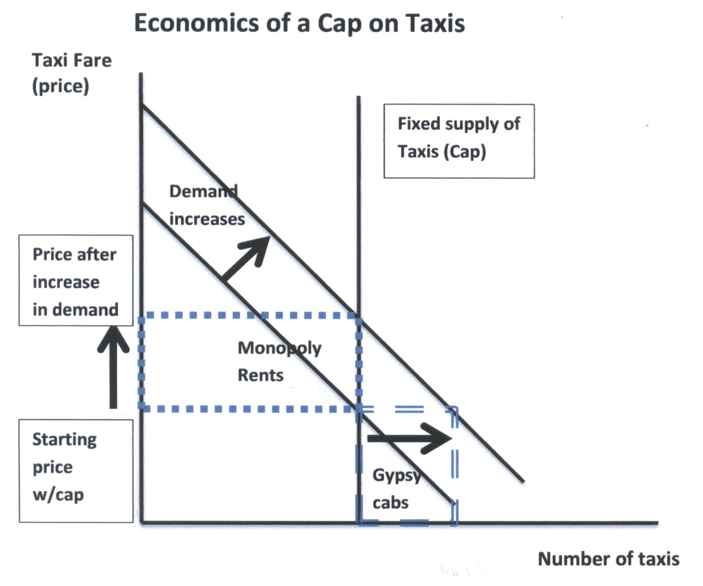

30. Milwaukee has allowed fares to increase but at a much slower pace than demand. As a result, taxis have become more scarce relative to demand. As long as company and vehicle owners believe the cap will stay in place (and supply will not increase), they will continue to buy vehicle licenses, usually through private sales, until all the monopoly rents are exhausted through bidding (the area of the box with the dashed lines). As we will see below, these incentives remain in place as long as the potential revenues earned from owning and operating an independent cab are greater than the cost of leasing a cab from an existing vehicle owner or company.
31. One consequence of a cap on supply is that current licensed drivers often have incentives to avoid the risk inherent in developing new markets. If the demand curve shifts out (for any of the reasons identified in footnote eleven), a portion of the market is not met when the supply of legal taxis is fixed. This unmet demand is represented by the double-dash box to the right of the vertical supply curve. The legal taxis focus on meeting the higher valued demand under the demand curve to the left of the fixed supply curve. The demand to the right of the supply curve will be met by illegal, or gypsy, cabs based on the willingness to pay by customers.
32. While this discussion may seem theoretical, these effects are in play in Milwaukee. Interviews with drivers and vehicle owners revealed that as recently as April 2012, taxi vehicle permits were receiving hard bids in the private market for $165,000 (August 2011) and $175,000 (March 2012). Some permit holders were refusing to sell, hoping that they would get as much as $200,000. In fact, one driver with knowledge of the bidders reported that a permit for sale in March 2012 had received three bids for $200,000 (although it’s unclear whether the sale was closed at this price). While these values may be inflated, prompting some skeptics to question whether private sales of licenses achieve prices of $150,000 or more, even current owners admit paying $80,000 per license recently. The taxi vehicle permit fee for the City of Milwaukee is $175, implying that the bids in the private market are direct and measurable evidence of a mismatch between the supply and demand for taxicabs in the Milwaukee market. The taxi vehicle cap creates an economic environment where potential cab owners will bid up the price of a permit until the monopoly rents are completely exhausted. This price will be higher than the permit price because the shortage created through the cap creates a perception that competition will not reduce revenues. These higher rents are not a result of consumers willingly bidding up prices for a better quality product. In fact, service quality may well have fallen. On the contrary, these higher revenues generated for current license holders are a near pure artifact of public policy that benefits existing vehicle permit holders at the expense of taxi users and potential entrepreneurs.
33. On a more practical level, limiting the supply of taxis in Milwaukee means the simple act of purchasing a legal entitlement to operate one taxicab in Milwaukee also requires financing a purchase equivalent to the value of a middle-income home. For example, the average residential property in Milwaukee was valued at $106,379 in 2012, down from $122,794 in 2011 and the peak of $133,000 in 2008 (before the recession). This point is worth exploring in more detail.
3.1 Effect of Taxi Permit Prices on Entrepreneurial Opportunity in Milwaukee
34. Permit prices in the tens of thousands of dollars effectively put vehicle ownership outside the reach of the typical taxi driver in Milwaukee. According to the U.S. Bureau of Labor Statistics (BLS), the average wage of a taxi and/or limousine driver in the Milwaukee metropolitan area is $21,850. This estimate, however, may be low. The BLS derives its annual figure based on an estimated hourly wage rate and then adjusts this compensation to reflect a typical full-time 40 hour work week and year (2,080 hours). Many drivers work on 12 hour shifts, six and sometimes seven days per week, indicating that work weeks involve hours significantly greater than 40 hours. Data from salary.com (accessed August 2, 2012) suggests a higher annual wage, reporting median taxi driver earnings in Milwaukee of $30,299. Half of the drivers make between $25,167 and $36,980, according to the salary.com data while 10 percent make more than $43,062.
35. Low earnings make purchases of taxi permits in Milwaukee particularly problematic. In some very large cities, such as New York, private financing companies have emerged to serve in the same role as a commercial bank to provide loans to private parties interested in buying and selling taxi licenses. Indeed, one company specializing in brokering sales for New York City taxi medallions is a publicly traded company on the New York Stock Exchange. No such options exist in Milwaukee, forcing potential taxi owners to finance the purchase of a permit from personal savings, second mortgages on existing homes, loans from family and relatives, or loans from friends.
36. To put these financial constraints in perspective, Table 3 estimates the annual payments needed to finance a taxi vehicle permit at three different prices and interest rates, assuming a 15 year commercial loan. While the prime rate—the interest rate charged to the best borrowers—may be lower than 4 percent, small businesses pay significantly higher interest rates because these loans tend to carry a higher risk of default. Even in today’s market, banks and commercial lenders are advertising rates significantly higher than 6 percent. These estimates should be considered conservative.
37. This is Table 3, detailing estimated annual payments needed to finance a vehicle permit, as explained in paragraph 36:
Table 3: Annual Payments Needed to Finance a Vehicle Permit
 | Annual Payments
Loan Amount | 4% | 5% | 6%
$200,000 | $17,760 | $18,984 | $20,256
$150,000 | $13,320 | $14,232 | $15,192
$100,000 | $8,880 | $9,492 | $10,128
Note: 15 year loan duration.

38. Even with these conservative assumptions, the financial commitment required to finance a taxi vehicle permit is substantial and daunting for the typical taxi driver. Table 4 calculates the estimated annual payments as a share of the median annual income estimated by salary.com. For a vehicle license over $150,000, nearly half of a driver’s income would have to be dedicated toward financing a 15-year loan at these interest rates. For comparison purposes, the rule of thumb in residential real-estate is that home buyers should not pay more than 30 percent of their household’s income annually for the mortgage. Clearly, the loan payments alone could jeopardize a taxi driver’s household income without the ability to increase his or her taxibusiness-derived income by 50 percent or more. In most cases, increasing income requires identifying and developing new markets for taxi services. The feasibility of developing new sources of income in a city with a cap on the number of vehicle licenses is less likely than one with open entry and is discussed further in the next section.

39. This is Table 4, detailing estimated annual payments as a share of the median annual income estimated by salary.com, as explained in paragraph 38.
Table 4: Financing Payments As Share of Median Income ($30,000)
 | Annual Payments
Loan Amount | 4% | 5% | 6%
$200,000 | 59.2% | 63.3% | 67.5%
$150,000 | 44.4% | 47.4% | 50.6%
$100,000 | 29.6% | 31.6% | 33.8%

3.2 Effects of Caps on Taxi Users
40. Given the highly concentrated structure of the taxi market in Milwaukee, consumers are likely to significantly benefit if the current cap were lifted. Drivers interviewed for this project indicated they believe unmet demand for taxi services exists in several Milwaukee neighborhoods, particularly in the northwest. This demand is not served by existing taxis and may be served by illegal gypsy cabs. Several drivers indicated that adding one or two vehicles would allow them to meet this new demand and implement a niche marketing strategy (e.g., neighborhood focused). These small microenterprises may also benefit from economies of scale and scope since some research suggests moving from one vehicle to two or three vehicles can lower operating costs.
41. While the consumer benefits of lifting caps is somewhat controversial in the academic research, the likely impacts for Milwaukee taxis will be positive because the reform would primarily influence the dispatch market and the city’s service areas that have low traffic density. Relaxed entry restrictions have been problematic in cities with very high traffic density because they create congestion at taxi stands and at airports. Interestingly, the research suggests that the perceived negative impacts are not on consumers. Indeed, increased competition among drivers for taxi users is typically considered negative in this research because driver’s report fewer trips and thus lower fares. These negative effects on drivers, however, are based primarily on the experience of high density traffic locations such as airports and taxi stands where additional cabs simply lengthen the queue. Consumers, however, benefit from greater choice, particularly if local regulations give consumers choice over the taxi they can hire as Milwaukee’s municipal code specifically allows.
3.3 Conclusion
42. In sum, the caps imposed by the city of Milwaukee likely reduce entrepreneurial opportunities by limiting the ability of drivers and others with few assets to purchase vehicle licenses to start-up or expand their business. The current cap favors incumbents and large companies by creating a significant financial hurdle for new entrants. Limiting the supply of taxis also constrains the ability of drivers in the current industry to identify and serve new markets such as those in the outer neighborhoods. The next section of this Affidavit examines these implications more completely by focusing on the specific operational characteristics of driving a taxi in Milwaukee.

- Economics of Driving a Taxi in Milwaukee
43. A key issue for the taxi industry in Milwaukee is whether the financial barrier of obtaining a taxi vehicle license influences the ability of new drivers to enter the market. While this effect was considered in Section Three, this section explores this question further by examining the specifics of taxi operations based on interviews with active drivers in the city of Milwaukee.
44. Importantly, drivers have little influence over market demand for taxi services absent the ability to provide new services or identify new markets. One consequence of the taxi shortage created by the cap imposed by the city is to encourage existing drivers and companies to ignore some markets with lower profit margins and focus on more lucrative markets with higher profit margins. These high value locations tend to be areas with high traffic density such as airports and downtowns. In many cities, the effect of these incentives is to focus on downtown markets, taxi stands, or businesses with reliable queues of potential customers. Outer neighborhoods with more dispersed, harder to serve markets are avoided. In terms of Figure 5, the outer neighborhoods would be represented by the market served by the illegal gypsy cabs.
4.1 Taxi Incomes and Wages
45. The taxi industry is not a high-income occupation, with drivers reporting incomes between $20,000 and $30,000 per year. Salary.com reports that Milwaukee’s annual median income for taxi drivers is $30,299, with half reporting earnings between $25,167 and $36,980. About 10% make more than $43,062. Using conventional rules of thumb in real-estate financing, just 10% of taxi drivers earn enough money to buy a house worth more than $130,000. Milwaukee’s taxi drivers appear to earn less than their colleagues in Minneapolis. Salary.com reports the median driver earns $33,455, with half making between $27,788 and $40,831 and the elite 10 percent earning more than $47,547. These earnings are higher than those reported by the U.S. Bureau of Labor Statistics (Table 5). In fact, when compared to the peer cities identified earlier, Milwaukee drivers earn less than the national average, Minneapolis-St. Paul, and Indianapolis, about the same as drivers in Columbus, and more than drivers in Cincinnati. Based on national data as well as city-specific data, taxi driver earnings are limited, creating a greater financial hurdle to generate savings sufficient to pay for new vehicles, let alone taxi permits valued on the private market in the tens of thousands and perhaps hundreds of thousands of dollars.

46. This is Table 5, detailing the estimated wages for taxi drivers in the Milwaukee metropolitan area along with those for peer economic regions:
Table 5: Estimated Wages for Taxi Drivers in Milwaukee Metropolitan Area and Peer Economic Regions
Metropolitan Area | Taxi Drivers & Chauffeurs | Hourly Median | Hourly Mean | Annual Mean
Milwaukee | 1,130 | $9.67 | $10.51 | $21,850
Cincinnati | 11,690 | $9.46 | $10.04 | $20,870
Columbus | 720 | $9.40 | $10.50 | $21,850
Indianapolis | 960 | $11.06 | $11.87 | $24,700
Minneapolis-St. Paul | 2,290 | $11.79 | $12.25 | $25,480
Nation | 166,890 | $10.94 | $12.03 | $25,020
Source: Data for taxi drivers and chauffeurs, Occupational Code 53-3041. U.S. Bureau of Labor Statistics, Metropolitan and Nonmetropolitan Area Occupation Employment and Wage Estimates, Occupational Employment Statistics, May 2011, http://www.bls.gov/oes/current, last accessed August 2, 2012.

4.2 Operational Costs of Driving a Taxi in Milwaukee
47. These constraints become more evident when the cost of owning, leasing, and operating a taxi in the city of Milwaukee is analyzed. As in any business, the operating expenses can be classified into two types: fixed costs and operating costs. Fixed costs are long-term investments and usually reflect expenses on capital equipment, such as vehicles, taxi meters and GPS. These costs are distinguished by their inability to be adjusted based on levels of output or service. A taxi driver, for example, needs a taxi regardless of whether she picks up one fare or several thousand. Operating costs, in contrast, are variable and change with the level of service, hours of operation, or output. These costs include gas, maintenance and dispatch services.
48. Based on data provided by drivers operating within the city of Milwaukee, a “typical” taxi driver who leases his car from another owner can expect to incur total annual expenses of at least $40,000 (Table 6). The cost for an independent owner is closer to $32,000. Notably, the purchase and financing of the vehicle is a relatively small expense—about $2,000 per year assuming a vehicle with a useful economic life of 5 years. Even if interest rates are substantially higher to reflect the higher risk associated with borrowing for this sector, the cost is well below $2,500 per year. Purchasing the vehicle permit adds 28.4 percent to the total cost of operating a taxi in Milwaukee at a 4 percent interest rate and 31.0 percent at a 6 percent interest rate.
Table 6: Estimated Annual Costs of Operating a Taxi in Milwaukee
 |  | Taxi Permit Financing Options
 | Lease | 4% | 5% | 6%
Vehicle Fixed Costs | $30,000 | $2,022 | $2,079 | $2,137
Maintenance | $0 | $3,600 | $3,600 | $3,600
Insurance (Vehicle) | $0 | $2,800 | $2,800 | $2,800
Gas | $10,400 | $10,400 | $10,400 | $10,400
Dispatch Services | $0 | $3,600 | $3,600 | $3,600
Taxi Vehicle License | $0 | $8,880 | $9,492 | $10,128
Total | $40,400 | $31,302 | $31,971 | $32,665
License Share of Total | 0.0% | 28.4% | 29.7% | 31.0%
Note:
- Fixed costs assumed purchase of a 5-year old car for $6,000, fully equipped with taxi meter and GPS, financed over the 5-year economic life of the vehicle;
- Taxi Vehicle License assumes a private sale of $100,000; finance estimates taken from Table 3.
49. This is Table 6, detailing the estimated annual costs of operating a taxi in Milwaukee:

4.3 Effects on Entrepreneurial Incentives
50. From an entrepreneurial perspective, the cost of the taxi vehicle license is a pure product of regulation—the value is determined solely by the cap on new taxis established by the city of Milwaukee. Indeed, it can be considered the shadow cost of regulation. Increasing the number of taxis to meet market demand would see the value of these permits fall to near zero, or perhaps a few hundred dollars if the buyer sees benefits from using an existing license rather than seeking approval for a new one. To compensate for the added cost of purchasing the vehicle license, a cab driver would have to identify new sources of revenue equal to or exceeding the cost of the license. In terms of the average income of a taxi driver estimated by the U.S. BLS, a taxi operator would have to identify a market large enough to increase his income by more than 50 percent simply to offset the higher cost of the permit before he would begin to earn a profit. This is a daunting financial hurdle for any micro-enterprise.
51. The data in Table 6 highlight another key element of taxi market operations that severely limits entrepreneurial opportunity: the lease system. Drivers consistently reported that lease rates for vehicles with established companies and owners averaged between $600 and $800 per week, although the higher lease rate also includes a controversial gas allowance required as part of a lease contract with one of the larger companies in Milwaukee. (Table 6 lease estimates are based on $600 per week.) Lease rates are the rent drivers pay to use vehicles owned by someone else. Lease rates are more than ten times higher than the amortized costs of purchasing and owning vehicles, and leasing a car is about one- third more costly than owning and operating a vehicle. As long as taxi fares and revenues are directed to existing vehicle owners through leases higher than the costs of owning and operating their vehicle independently, drivers are inherently constrained in their ability to save enough money to purchase their own vehicle and begin their own cab companies.
4.4 Conclusion
52. Given the inequity in the lease value versus vehicle financing, existing cab companies have an inherent advantage over current drivers because the profits they generate off the leases, which are also higher as a result of the limits on competition through the new vehicle license moratorium, allow them to purchase additional vehicles and purchase a permit on the private market. These estimates suggest that two years of lease payments would generate sufficient revenues to purchase a permit priced at $100,000 on the private market (Table 3). Three years would be sufficient to generate revenues to purchase a permit at $150,000. Absent the cost of a vehicle permit, the financial barriers of starting-up or expanding a small taxicab company are substantially more manageable given the relatively low wage nature of the industry and the narrow profit margins on which taxis operate. The fiscal impacts of expensive vehicle licenses also reinforce the concentrated nature of the Milwaukee taxi market by providing large companies a financial edge in financing the expansion of their fleets.
- Economics Effects of Expanding the Taxi Fleet in Milwaukee
53. The previous sections of this Affidavit outlined several important and significant barriers to economic opportunity in the Milwaukee taxi market presented by the city’s current taxi vehicle cap. The current cap acts primarily to:
- Reinforce concentration in the taxi market;
- Give existing vehicle license holders a significant economic advantage via the leasing system;
- Limit revenue and earnings potential for existing drivers by creating significant barriers to owning and creating new taxi companies.
54. This section explores the potential impacts of expanding the taxi fleet in Milwaukee to encourage economic opportunity and the expansion of taxi services available to Milwaukee residents and visitors. Unfortunately, the analysis is necessarily speculative since the cap has been in place for twenty years. Nevertheless, examining the effects of open entry in other cities may provide insight into the potential impacts in Milwaukee of relaxing or eliminating the current effective cap.
5.1 The Effects of Lifting the Cap on Taxis
55. Minneapolis represents the most recent case of lifting a cap on taxis in the U.S. Minneapolis introduced legislation in 2006 to lift its cap of 343 taxis and began a process of incrementally increasing the number of licenses each year by 45 permits. A coalition of taxicab company owners sued in April 2007 in an effort to prevent the city from increasing permits. Meanwhile, the city continued to grant additional permits, allowing the fleet of taxis operating in the city to expand to 523 by June 2009. The taxi owners lost their suit in the lower courts, but appealed. After the federal Court of Appeals ruled against the taxi owners, and the U.S. Supreme Court declined to review the appeals court decision, the cap was lifted completely in January 2011. As of December 31, 2011, 821 taxis were licensed to operate in the city of Minneapolis, an increase of 139 percent.
56. The Minneapolis experience, however, is likely an extraordinary case. Some of the growth of licenses in Minneapolis may be an artifact of the local licensing process. Many of the new licenses, for example, were duplicates secured by cab companies that served the airport, which has independent licensing authority. The city of Minneapolis also grew substantially during the 1990s under the cap while the supply of taxis remained constant. The city of Milwaukee, in contrast, lost population over the last two decades. Experience from other cities deregulating entry into their taxi market suggests that the increase will most likely be more modest, perhaps closer to 20 percent. This implies an additional 64 permits in the city of Milwaukee.
57. In addition, the profile of the typical cab driver is likely to be different if the cap is lifted. New permits could be issued for:
- Current drivers who want to own and operate their own car rather than lease;
- New drivers servicing new markets, such as neighborhoods not currently adequately serviced;
- New drivers who prefer working part-time without the revenue pressure generated by a lease arrangement.
5.2 The Potential Role of Part-Time Drivers
58. The role of part-time drivers is particularly important since this is the group that is likely to make up most new permit holders under a deregulated entry system. While many full-time drivers may fear that new vehicles will dilute their incomes, this is not necessarily the case. New drivers, particularly part-timers, are likely to serve peak period demand at specific times of the day that already experience a shortage of taxicabs. They will be meeting demand that current cab companies cannot meet given existing supply constraints. Current drivers already note that significant waiting times for taxi customers exist at major sporting events, and these would be natural points where additional taxis could better serve the general public without reducing revenues for current or full-time drivers.
59. Even on routine days, fares are not evenly distributed throughout the day. Unfortunately, Milwaukee-specific data on trip and fare distributions were not available for this report. Nevertheless, some insight might be gleaned from patterns and data collected for another city: Port Chester, New York. Port Chester and Milwaukee are not strictly comparable. Port Chester’s taxi market is very dense, with substantial portions of the taxi fleet providing trips such as transporting children to school, senior citizens to shopping and medical appointments, conventional airport trips, and commuters arriving at a local train station in a small geographic area. The taxi market is thus “thick” in the sense that demand is concentrated and not dispersed. The Port Chester data reflect patterns in a city with a taxi industry thoroughly integrated into the transportation system and network. In this sense, the taxi market in Port Chester represents a mature market serving a wide range of transportation needs. Thus, examining fare and trip patterns might provide an indication of how a market might operate if it were more fully developed than currently in Milwaukee. More importantly, the data provide rare insight into differences in behavior and opportunities for full-time and part-time drivers.
60. Figure 6 provides data on radio dispatched trips from Port Chester collected by me for a previous study. The data for Port Chester peak during commuting times (between 7 am and 9 am), around the lunch period and late afternoon. These distributions may not parallel Milwaukee precisely, but they are useful to illustrate a point: Trips tend to be distributed unevenly throughout the day, clustering around high demand parts of the day.

61. This is Figure 6, detailing the distribution of dispatched taxi trips by hour of the day in Port Chester, NY:
Figure 6
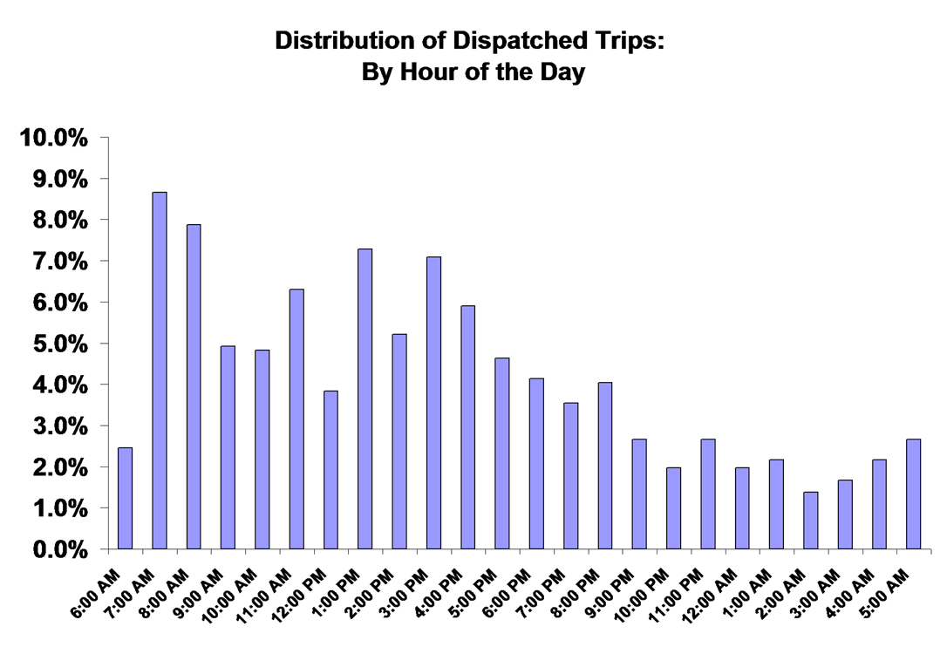
62. The role of part-time and full-time drivers is shown directly in Figure 7 using additional data from Port Chester. Part-time drivers tend to focus on the peak morning commute times and late evening trips, while full-time drivers tend to be active throughout the day and provide services during the lunch and afternoon hours. To more fully understand these dynamics, the trip patterns for the most active full-time and part-time drivers in Port Chester were compared (Figure 8). The full-time drivers are clearly more active during “regular” business hours, the morning and afternoon commutes and lunch. Part-time drivers have much more specific preferences. Part-time driver No. 1, for example, is active in the evening and collected no fares during the lunch and afternoon hours. Part-time driver No. 2 was most active at lunch. Part-time driver No. 3 served morning commuters and evening. Thus, part-time drivers tend to adapt their schedules based on the level of demand and personal preferences for driving a taxi. Similar patterns should be expected to occur in Milwaukee if the taxi fleet expands.

63. This is Figure 7 and Figure 8, detailing the distribution of taxi trips and fares, respectively, by period of day, full time versus part time drivers, in Port Chester, NY:
Figure 7
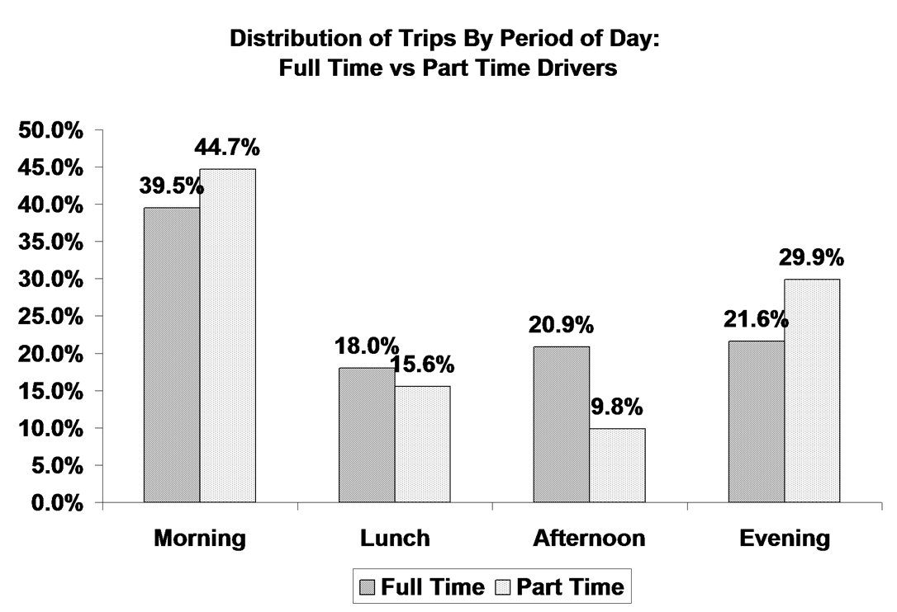
Figure 8
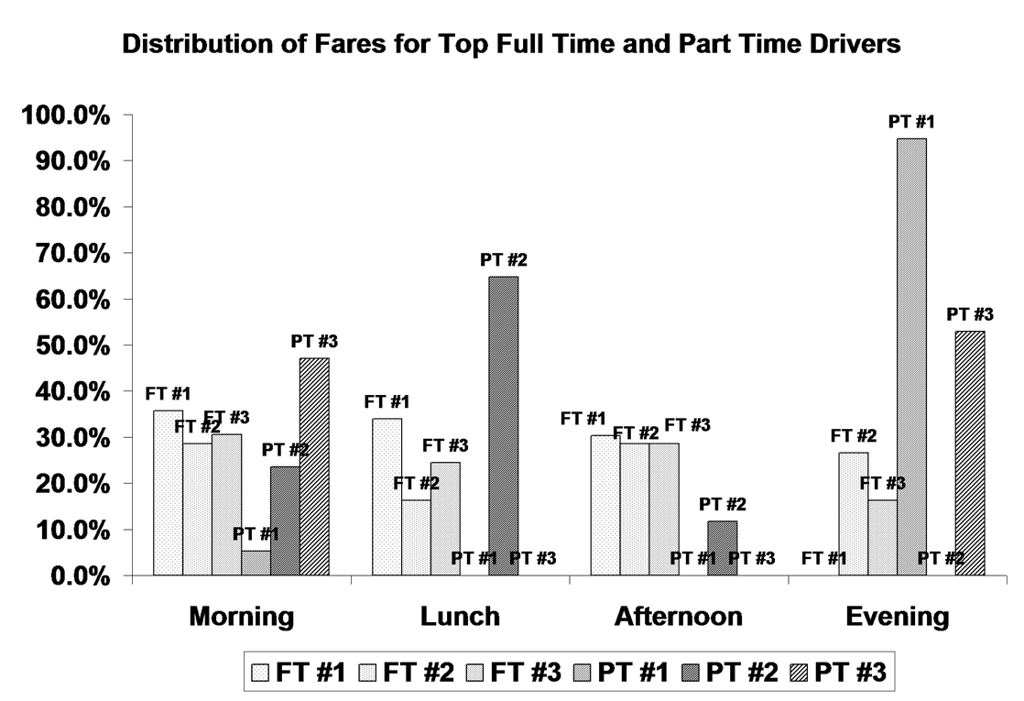
5.3 The Potential for Innovation
64. The Port Chester data are useful because they reflect data from a “complete” taxi market, one that serves not just high volume areas and high margin trips. Taxis serve a variety of mobility purposes in the larger neighborhoods. Thus, the expansion of the taxi market in Milwaukee may allow for the evolution of a more complete taxi market that serves the needs of neighborhoods and residents more fully.
65. An important source of potential revenue will come from the expanded markets served through innovation within the Milwaukee taxi market. Even in the case of Minneapolis, the addition of hundreds of taxis meant that new markets and customers were being served. In at least two cases, cab companies have emerged to serve specific neighborhoods that were previously poorly served by the existing taxi market. Similarly in Milwaukee the addition of new vehicles suggests that new customers will be served and possibly new markets will be created. As the data on part-time drivers from Port Chester imply, new taxi drivers and companies may specialize in serving particular types of customers, including the senior citizens, medical trips, ethnic neighborhoods, or even a higher income business clientele. These markets cannot be served without a substantial increase in the number of taxis and taxicab companies.
- Conclusions
66. This Affidavit examined the likely effects of the cap on taxis in the city of Milwaukee and on the taxi market and industry dynamics. The current market is highly concentrated, with nearly 60 percent of the licenses owned by just three individuals or companies. The current cap has created a substantial and meaningful constraint on entrepreneurs entering the market by imposing an excessive financial burden on current drivers and microenterprises. The regulatory effect of the vehicle permit cap is to generate a private market for permit sales that exceeds $100,000 per permit. As a result, current vehicle permit owners and large cab companies have an inherent advantage over new entrants and start-ups.
67. The result is a taxi market economically hostile to start-up businesses and the expansion of microenterprises such as single permit holder taxicab companies. By limiting the expansion of microenterprises, new markets are not developed or tapped and levels of service are lower than they would be with a larger citywide taxi fleet.
In sum, the analysis in this report suggests that the current taxi vehicle cap in the city of Milwaukee
- Encourages concentration and consolidation among a few very large companies;
- Limits the entrepreneurial opportunities for existing drivers by creating significant and unnecessary financial barriers to entry; and
- Discourages entry and innovation in the Milwaukee taxi market, leading to lower levels of service.

___________________________________
Samuel R. Staley

Subscribed and sworn to before me this ____ day of October, 2012.

__________________________________
Notary Public, State of Florida

Notary No. __________________________

My Commission expires _______________.

The city has reported 321 permits, but I had data on 319 provided by the city. The terms “license” and “permit” are used interchangeably throughout this Affidavit. No difference in legal interpretation or meaning is implied. The term “license” is used solely to refer to the legal permission to operate within a specific municipality and does not imply stipulations, regulations, or limits beyond this function.
The data used in this Affidavit is insufficient to comprehensively examine cab vehicle and company management relationships. These data only refer to individuals and business entities with a legal license to operate a taxi in Milwaukee.
No attempt was made to determine or identify additional business relationships among license holders and owners beyond the information reported and identified by the city’s roster of license owners. Also, the terms “license owner” and “license holder” are used interchangeably in this Affidavit since the licensee has operational and business control over the use of the vehicle permit.
Other cities were also considered based on city population size, including Nashville-Davidson, Washington, DC, Oklahoma City, and Denver. These cities were rejected as “peer” cities for separate reasons. Washington, DC, as the national capital and part of a metropolitan area many times larger than Milwaukee, has a taxi market dynamic that is significantly different catering to the political market as well as international tourism. Oklahoma City does not license taxicabs or taxi drivers, thus this data is not available. Denver’s taxi market is highly regulated by the state department of public utilities. Thus, the regulatory environment was significantly different from the other peer cities. We were unable to obtain sufficient information from Nashville-Davidson County to make meaningful comparisons to meet the deadline for the report that preceded this Affidavit.
These data refer to ownership as listed on official records provided by the city. They do not necessarily reflect effective control through family relationships or individual influence. For example, Michael Sanfelippo operates American United Taxi in Milwaukee even though many of the licenses are listed as owned by Joe Sanfelippo Cabs, Inc. By one public account, Michael Sanfelippo controls 162 permits, an amount greater than the number used in this Affidavit. See Bruce Vielmetti, “Cab Drivers to Sue Milwaukee Over Limit on Caps,” Milwaukee Journal-Sentinel, September 25, 2011, http://www.jsonline.com/news/milwaukee/130609278.html, last accessed August 3, 2012.
Note that these data refer to individuals or corporations who own licenses, not cab companies or individuals who may own multiple companies with licenses. Companies may consist of multiple vehicles owned by several individuals. Similarly, one individual may have an ownership stake in more than one company that owns vehicle licenses. So, two companies, say ABC Taxi, Inc. and XYZ Taxi, Inc. might independently own 10 licenses, and they would be counted as two companies in this analysis even if they were owned or controlled by the same individual or group of individuals.
In fact some drivers report that several dozen licensed taxi vehicles are kept off the market in Milwaukee by some owners. Thus the actual number of vehicles on the road at any given time might be fewer than 319. This withdrawal of taxis from active service, however, is more likely a result of current owners using their influence in the existing market to artificially constrain supply than a direct intention of public policy.
The source of this shift in demand could be varied. In some cases, population and economic growth would drive up demand. In other cases, higher incomes would increase demand as people on lower ends of the socioeconomic spectrum can now afford to use taxis rather than ride on slower buses or walk. Yet another factor could be technology. The use of cell phones, for example, may make conventional dispatching services less valuable while also allowing taxi drivers to develop niche or specialized markets that could not be tapped previously. Still other innovations might be product-oriented, where an entrepreneurial taxi driver develops a business relationship with restaurants or bars to provide on-demand service to clients. In one city, a taxi company relied primarily on contracts with the local public transit agency to provide paratransit or emergency pick-up and delivery in the event of an equipment (e.g., bus) breakdown.
Notably, not all cities regulate taxi fares. Stockholm, Sweden, for example, does not regulate fares. Taxis are required to post their fares and customers are permitted to negotiate with drivers. In a study of taxi regulation in eight Ohio cities, two did not regulate fares at all, four set maximum rates, and two set the rate by municipal ordinance. For the Ohio data, see Taxi Regulation in Ohio’s Largest Cities, The Buckeye Institute, 1996, http://www.buckeyeinstitute.org/docs/taxistudy1.pdf, last accessed August 3, 2012. For Stockholm (and Sweden more generally), see http://www.visitstockholm.com/en/Travel/In-Stockholm/Tips-In-Stockholm/Taxi-/, last accessed August 3, 2012.
The term “monopoly rent” and “economic rent” is a technical term used in the academic and professional literature on economic regulation. For the application of this concept to regulation, see Robert Tollison, “Rent Seeking: A Survey,” Kyklos, Vol. 35, no. 4 (1982), pp. 575-602.
In interviews, drivers reported gypsy cab activity in Milwaukee in outer neighborhoods such as the northwest regions of the city.
During the winter of 2012 the Wisconsin legislature considered but failed to approve a medallion system which many thought would ensure the taxi market would not expand, thus bidding prices of existing licenses up. For permit price data, see Bruce Vielmetti, “Cab Drivers to Sue Milwaukee Over Limit on Permits,” Milwaukee Journal-Sentinel, Sept 26, 2011, http://www.jsonline.com/news/milwaukee/130609278.html, last accessed August 3, 2012.
“Property Values Fall,” Milwaukee Journal Sentinel, JSOnline, April 27, 2012, http://media.jsonline.com/images/ASSESS28G.jpg, last accessed August 3, 2012. See also Larry Sandler, “Milwaukee Property Values Fall See Biggest Drop in 30 Years,” Milwaukee Journal Sentinel, April 27, 2012, http://www.jsonline.com/news/milwaukee/milwaukee-property-values-see-biggest-drop-in-30-years-v556or2-149315155.html, last accessed August 3, 2012.
This would work out to a $10 hourly wage rate on a 60 hour work week, about the same hourly wage rate estimated by BLS (and discussed more completely in the next section).
See Michael Grynbaum, “2 Taxi Medallions Sell for $1 Million Each,” City Room Blog, New York Times, October 20, 2011, http://cityroom.blogs.nytimes.com/2011/10/20/2-taxi-medallions-sell-for-1-million-each/, last accessed August 11, 2012.
Drivers interviewed for this research identified family and friends as the principal source of funds for buying vehicle licenses, not formal commercial lending institutions. For example, a driver might borrow from relatives who own a profitable neighborhood business. Interest rates and terms were not disclosed during the interview process. These informal lending arrangements often carry higher interest rates and shorter loan-payback periods.
For a review of the academic research on taxicab regulation by economists, see Adrian T. Moore and Ted Balaker, “Do Economists Reach a Conclusion on Taxi Deregulation?” Econ Journal Watch, Vol. 3, No. 1 (2006), pp. 109-132, http://econjwatch.org/articles/do-economists-reach-a-conclusion-on-taxi-deregulation, last accessed August 11, 2012. A comprehensive review of the research on the effects of entry restrictions on the taxi market can be found in Bruce Schaller, “Entry Controls in Taxi Regulation,” Transport Policy, Vol. 14 (2007), pp. 490-506.
Milwaukee Municipal Code, Chapter 100-60, “Additional Operating Regulations,” Section One, reads: “METER FARE TAXICABS. a. Taxi Stand Use. a-1. No taxicab standing at the head of a taxi stand line shall refuse to carry any orderly person applying for a taxicab who agrees to pay the proper fare, but this shall not prevent any person from selecting any taxicab he or she may desire on the stand whether it be at the head of the line or not.”
See Samuel Staley, “A Taxi Medallion System in D.C.? The Neighborhoods Will Pay the Price,” Washington Post, April 1, 2011, http://www.washingtonpost.com/opinions/a-cab-medallion-system-in-dc-the-neighborhoods-will-pay-the-price/2011/03/31/AFLlGcJC_story.html, last accessed August 3, 2012.
Bruce Schaller, “A Regression Model of the Number of Taxicabs in US Cities,” Schaller Consulting, January 2005, www.schallerconsult.com.
In fact, drivers in Milwaukee argue that neighborhoods in the northwest part of the city and near many popular stores are not served by existing taxis and represent a market they would target if they were able to obtain a taxi license.
Data from Salary.com using the search term “taxi driver,” last accessed August 2, 2012, http://swz.salary.com/SalaryWizard/Taxi-Driver-Salary-Details-Minneapolis-MN.aspx.
The figures used in this section were compiled by me from discussions from nine independent drivers in the city of Milwaukee interviewed on April 30, 2012 and May 1, 2012. The following monthly figures were used for the basis of the variable operating expense estimates: lease: $2,400; dispatch services: $450; maintenance costs: $300; gasoline: $800. This may imply lower expenses than for some drivers; one driver reported in an interview annual expenses in the previous year (2011) of $24,000.
For an examination of the impacts of the leasehold system on driver opportunities and income, see Bruce Schaller, “Villain or Boogeyman? New York’s Medallion System,” Transportation Quarterly, Vol. 50, No. 1 (1996), pp. 91-101.
During the period in which the data were collected in Port Chester, the city had a cap on vehicle licenses and cab companies and was investigating the possibility of removing both caps.

