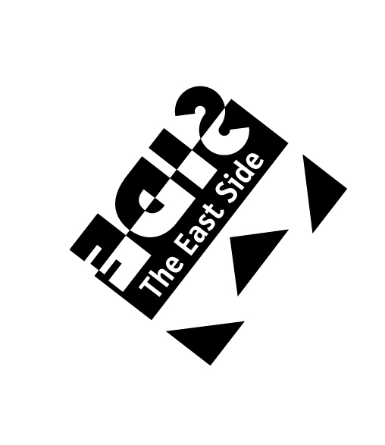
East Side Business Improvement District #20
2122 N. Prospect Ave.
Milwaukee, WI 53202
414-272-5823
Staff: Executive Director, Jim Plaisted
eastsidebid@gmail.com

East Side Architectural Review Board

Alderman Nik Kovac, Chair
Lynn Sbonik, Secretary
James Piwoni, Lora Keller, Lincoln Fowler, and James Friedrichs, members

THURSDAY, October 3rd, 2013
12:00 PM to 1:30 PM
UWM Kenilworth Apartments Building, 1915 E. Kenilworth Pl., Room 211

Meeting Agenda

- Call to order

- Approval of minutes from September 3rd meeting

- Old Business

  - Joseph Property Development, 2239 N. Prospect Ave. Certificate of Appropriateness for revised building material on apartment building portion of the redevelopment.

  - Joseph Property Development, 1800 E. North Ave., Certificate of Appropriateness for construction design details, building materials and landscaping/lighting plans for a four-story new construction development featuring 39 apartments and first floor commercial space.

- Adjournment

Upon reasonable notice, efforts will be made to accommodate the needs of persons with disabilities through sign language interpreters or auxiliary aids. For assistance, contact the Legislative Services ADA coordinator at 286-2998, FAX (286-3456, (TDD)286-2-25 or by writing to Room 205, City Hall, 200 E. Wells St., Milwaukee, WI 53202

Persons engaged in lobbying as defined in s. 305-43-4 of the Milwaukee Code of Ordinances is required to register with the City Clerk’s office License Division. More information is available at www.milwaukee.gov/lobby or by calling 414-286-2238.

